January 29, 2005

Dear Friends –
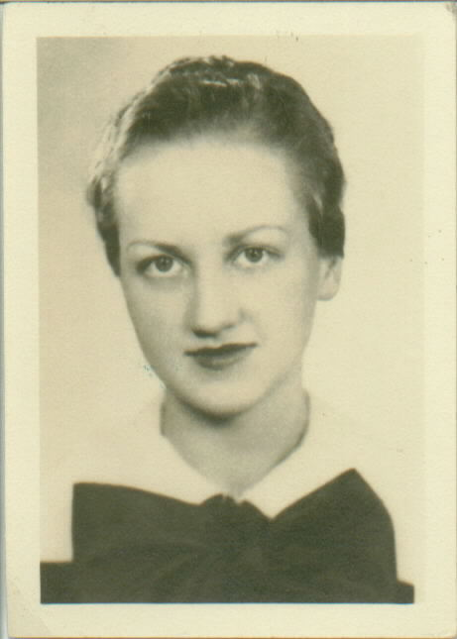
I have taken some extra time to respond to you and I apologize for the delay. But there have been so many expressions and tokens of sympathy and support over the loss of my mother that I have simply been basking in them and collecting them.
I guess I did not anticipate so many people taking the time to offer condolences and have truly been touched by them. Each one was very appreciatively received and enjoyed.
My mother died on New Year’s morning, right after my return from a 4 day visit to her bedside in Ohio. It was a good time with her, albeit brief. She slept most of those days away, only to awaken every few hours and for only a few moments. But when those times came, I tried to be there and have something new to tell her so that we could enjoy the time together. She did not seem to be in any pain but the weariness was evident upon her face.
She said more than once that she was “ready to go home”. As she had spells at the last when she was not in touch with reality, I wasn’t completely sure what she was meaning by that. But the more we talked, the more I was convinced that she knew what she was talking about and longed to be at rest in the presence of God and the company of other loved ones gone before.
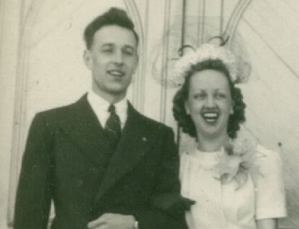
That fit in well with the kind of woman she always had been. Over the past 15 years, particularly, I have gotten to know my mother as a widow in a way I hadn’t had the opportunity to do before my father died. Mom was a woman of deliberate mind. She made difficult decisions by herself and faced the necessary transitions required of her due to increasing age and decreasing independence with grace and dignity, even when her condition did not allow her the dignity she really deserved.
For that reason, she was never really satisfied or comfortable in the Green Hills Center, the acute care facility where she lived for the last two and a half years. She insisted on spending her waking hours in a wheelchair - even though to do so was bad on her back and posture - simply because it was the last vestige of independence and self-expression she had left. But during that time, she was still a lady, handling what she had to and speaking up when she felt she had a right to do so.
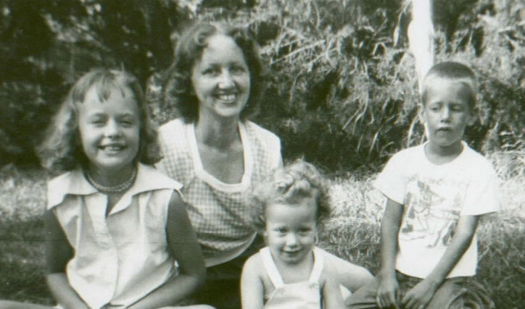
It was because of all of this that I felt very torn during her last years. I truly wanted to give her all I could to make her more comfortable and satisfied. But as she declined, the distance became more and more the problem and I felt less and less able to be of any help to her at all. Being in that position is truly a helpless feeling.
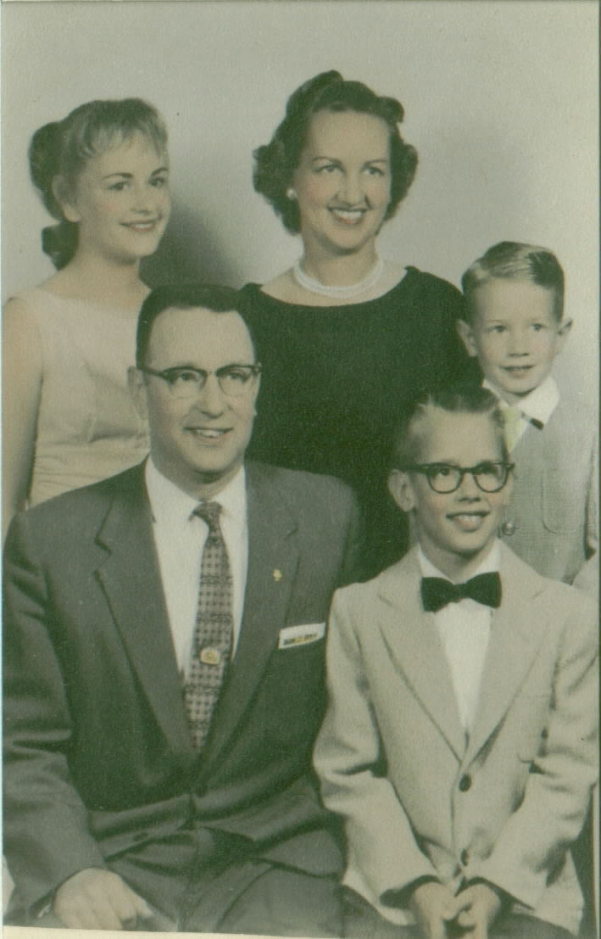
When she died, I was very thankful that her lingering in such a bed-ridden condition was not extended far beyond the days I could spend with her. The Lord was very merciful to her in so many ways.
Your thoughts and prayers were very beneficial to me and I am overwhelmed by the fact that so many people thought to support me and my family so much. Once again, I thank you very much.
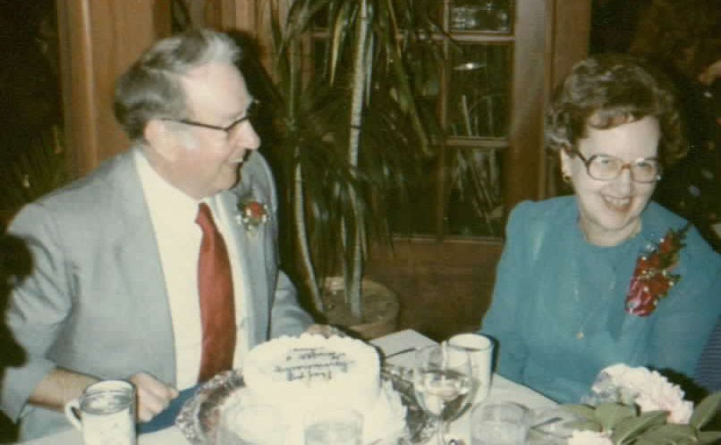

May God bless us all with dignity and strength as we, each one, face the end of our days, trusting in the one true Lord, the maker of heaven and earth, and the Father of our Lord, Jesus Christ.

May God bless you richly,

Dave Barker

