Memorial Thoughts regarding my Uncle Bryce Warne

Bryce Warne, who, many years ago, was minding his own business, raising his own family, and who, in many ways was quite happy with his life, was, through no fault of his own, mind you, one day confronted with the unavoidable fact that he had become my uncle. I was the youngest of 3 born to his older sister, who, Bryce thought, lived comfortably far away in Texas.
It also was not his fault that his brother-in-law, my father, worked for a major airline which allowed its employees - and their family members – the perk of flying very inexpensively anytime they might want to and go wherever they wished to go.
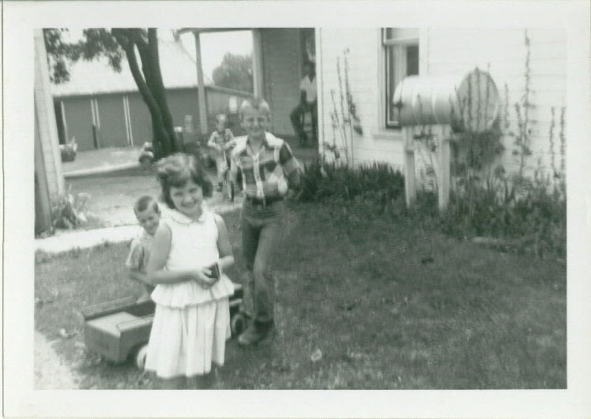
But it was this mysterious combination of circumstances that allowed for me, his newest nephew, who in reality was, perhaps not distant enough, to begin his annual pilgrimages of prolonged visitation to the otherwise serene, peaceful and pleasant Warne family farm most every summer of my formative years.
Make no mistake about it, I was an obnoxious, self-humoring, self-entertaining, runny-nosed city kid who would come every single, solitary year and commence to make myself quite at home at the expense of and, very often to the great humor of the rest of the family.
Even as I write these words, the most embarrassing, long-forgotten, incredible memories began, once again, to flood my mind. Most of those memories I would have to tell at my own expense. But I don’t have to do that because I know that my own, dear, loving and revengeful cousins would take much more delight in their own recounting of those memories than I would.
When I was at the farm, I wanted to be a farmer. And Uncle Bryce was willing to take that just about as far as his sense of conscience and self-preservation would go. One thing he loved to do when I first arrived was to put me on the morning rotation. That meant getting me up at some unheard-of hour just a little after midnight, I’m sure, putting me in the car and drive me out to the middle of nowhere, dropping me off and telling me to walk through the fields back to the barn! Now, my cousins had all prepared me for this. They said this was called “driving in the cows” and that it was great fun. And sometimes I would, indeed, come across a cow or two, which seemed at the time to make it all worthwhile. And every morning that I would get up with Bryce in such a way, he offered me a banana to eat which, he said would tide me over for the several hours remaining until breakfast. I still think that it was trekking over manure-strewn cow pastures in the middle of the night all alone that made me lose my appetite for bananas.
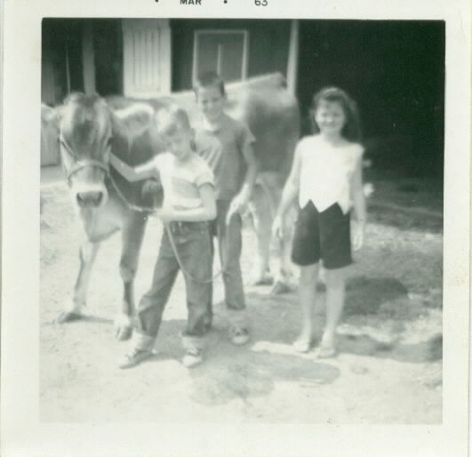
I learned a lot during those summers. I learned how heavy a cow is when she stands on your foot. I learned that I mustn’t spook the cows before milking but how much fun it was to chase them after. My favorite place and time was the milking parlor at milking time – the tails swishing the flies, the conversations, the rhythm of the pump. And, with my mind’s eye, I can still see Bryce as he would go through his routine - bend down by a cow, test to see if she was done by squeezing the tube, reach up to turn off the vacuum, pull the milker off and carry that heavy load in one hand with the hose draped over his shoulders. I remember the dark spot on the right hand wall where he would take the one step down, grab the wall with his right hand and swing into the milkhouse; how he would step up on the cinder block to get above the huge, stainless steel funnel, lift one or two of those “udder thingies” to let off the vacuum with a “whoosh”, lift off the lid – a sound which echoed in that small room - and pour out the milk into the tank, managing to get the last of it by lifting it up with his right leg. If Bryce was anything, he was methodical. And he was always patient with me in spite of how bizarre I might act. But I am also sure they all breathed a sigh of relief when my summer visit came to a close and I flew home.
After I grew up, those annual trips to the farm became a thing of the past and for several years I only kept up with the Warne family through my mom and dad, and eventually, just through mom.
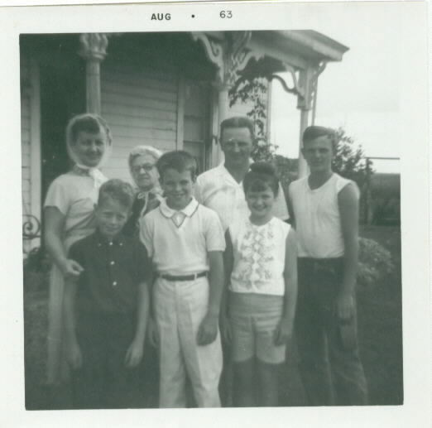
When we renewed acquaintances again, I noticed that things had changed. Bryce had retired, moved and had begun to enjoy other things. But in those latter days I also met a new side of Uncle Bryce, something had changed his heart, had turned him around, had given him a new lease on life and a new topic of conversation. And, no, I’m not talking about Keylation.
Mom coming to pick me up for the trip home. Notice everyone is smiling but me!
Bryce was a committed Christian who wasn’t afraid to wear it on his sleeve and his lapel, and to express it with his words and thoughts. Oh, sometimes it could test your patience. But he had a good witness, with solid, provocative thoughts and more than one challenging question.
And there was one more thing. He was devoted and attentive to his entire family. I saw that first-hand growing up on that farm, where he cared not only for his own family but his aging mother as well. And even later, as a young family man myself I saw his delight in the prosperity of his children and their pursuits. But I also saw it in one more demonstration – I saw it when my mom, Bryce’s older sister, moved back into his “neck of the woods” to live out her senior years. At first, my mom wondered if Bryce might be too protective, too present in her new life there. But he wasn’t. Instead, my mother grew to want his kind and loving visits even more than he could give to her. It was a kind thing he did, to be her younger brother. She never forgot that.
Prov. 21:21 says “He who follows righteousness and mercy finds life, righteousness and honor.” That’s the memory of my Uncle Bryce – he gave himself to the care of his family, to his mother, to a nephew reveling in his immaturity, and then later, to the attention and compassion for his needy sister.
I am much obliged, Bryce.

David G. Barker, April 1, 2006

