**Studies in the Book of 1st Corinthians**

***God’s Wisdom to a Dysfunctional Church***

**Called to be Saints**

*1 Corinthians 1:1-9*

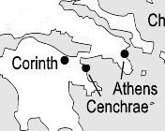

(see also: Acts 18:1-17; Phil. 3)

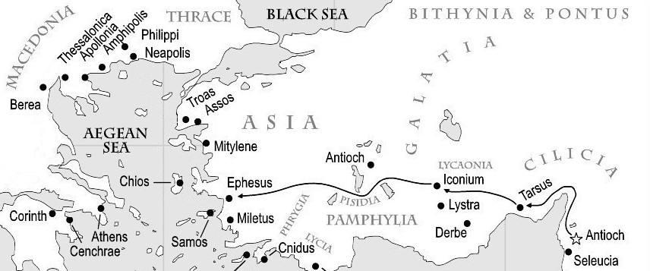

The two principal advantages to the location of ancient Corinth:

a) a nearby McDonalds and Redbox.

b) the Akrocorinth and Isthmus of Corinth.

c) E. A. Poe Stadium & the Fighting Geckos.

Can we closely approximate when this letter was written?

Might there have been a third letter of Paul to Corinth?

Vs. 1 – apostle Paul & Sosthenes

Vs. 2 – the church in Corinth

Vs. 4-9 – the prayer of Paul

How important is it to be a part of the visible church today?

How important is it to me to find the “perfect” church?

New Covenant Presbyterian Church, PCA, Abingdon, MD (410) 569-0289

**Studies in the Book of 1st Corinthians**

***God’s Wisdom to a Dysfunctional Church***

**Are Separate Denominations Sinful?**

*1 Corinthians 1:10-17*

(see also: Acts 18; 1 Cor. 2:1; 16:12)

The only good church

a) is the one I approve of and attend when I choose.

b) is the one which I control & which goes my way.

c) is the one that preaches Christ.

I. The first issue is ___________________ (vs. 11-12)

Is Paul advocating “unity at all costs”?

1. Truth requires _____________________.

2. The curse of Gen. 3 must not be _________________.

3. Truth must be distinguished from __________________.

II. The second issue is _________________________ (vs. 13-16)

The subject is not water baptism but:

III. The third issue is the _______________ of Christ. (vs. 17)

What is the basic difference between these?

oratory

preaching

What might be causing the dissension in Corinth?

What could well be the result?

Do I respond to oratory or to preaching?

New Covenant Presbyterian Church, PCA, Abingdon, MD (410) 569-0289

**Studies in the Book of 1st Corinthians**

***God’s Wisdom to a Dysfunctional Church***

**What Must Christians Demand?**

*1 Corinthians 1:18-31*

(see also: Jn. 3; Acts 9; Rom. 1:16-17)

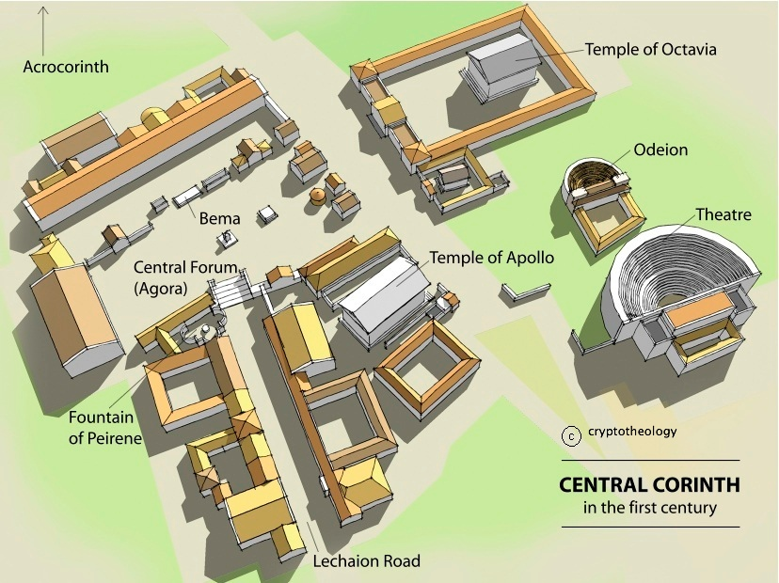

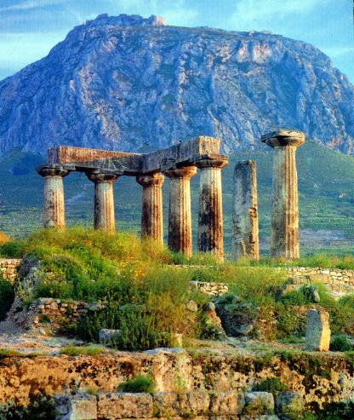

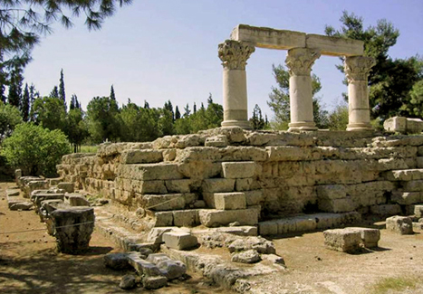

**I. What are the basic principles of the gospel? (vs. 18-19)**

#1

#2

#3

**II. Who are the scribes? (vs. 20)**

**III. The problem with worldly thinking. (vs. 22-23)**

Jews -

Gentiles –

**IV. Points to learn:**

#1

#2

#3

Have I known the power of God’s transformation in my life?

New Covenant Presbyterian Church, PCA, Abingdon, MD (410) 569-0289**Studies in the Book of 1st Corinthians**

***God’s Wisdom to a Dysfunctional Church***

**The Necessity of the Holy Spirit**

*1 Corinthians 2:1-16*

(see also: Is. 55:8; 64:4; Jer. 23:18; Acts 17)



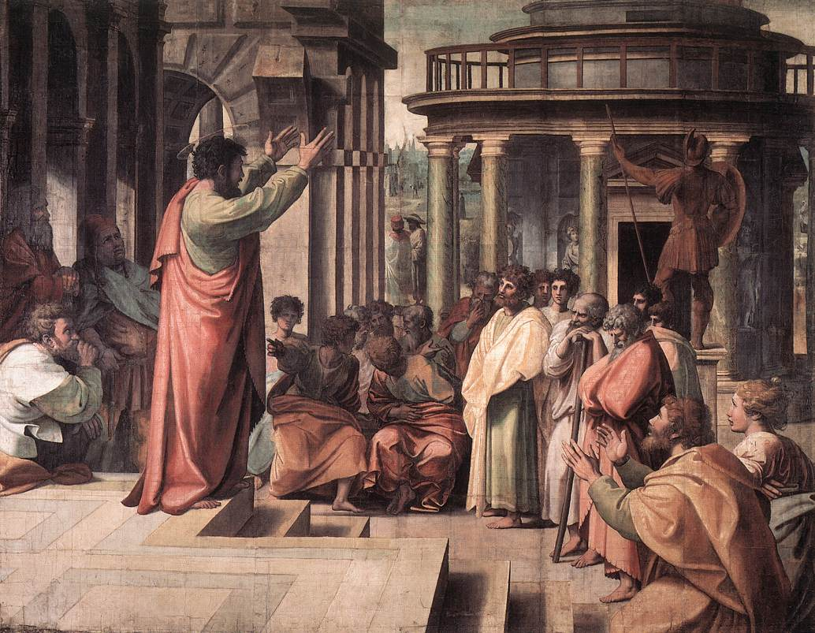

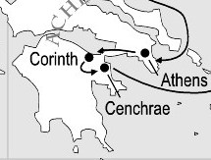

Route of Paul’s 2nd

Missionary Journey

Acts 17 on Egyptian

Papyrus, 250 AD

Paul preaching in

Athens, Raphael, 1513

In Acts 17, Paul spoke

a) down Jupiter Row.

b) in Pluto’s Mall.

c) on Mar’s Hill.

**I. Paul has been battling two fronts.**

#1

#2

(True/False) The power/presence of the Holy Spirit will solve any/all theological disputes.

**II. What is Paul saying in 2:1-5?**

How does Acts 17 help us answering this?

Should a spiritual pastor diligently prepare for and practice his preaching or just depend on the Spirit?

**III. What does the work of preaching do? (vs. 7-16)**

Is the gospel a closely guarded secret?

What must you do if you are convicted by the Holy Spirit?

First, you must:

Second, you must (vs. 6):

Was the Corinthian church very mature?

Will I determine to become mature in my faith?

New Covenant Presbyterian Church, PCA, Abingdon, MD (410) 569-0289

**Studies in the Book of 1st Corinthians**

***God’s Wisdom to a Dysfunctional Church***

**The Holiness of God’s Temple**

*1 Corinthians 3:1-23*

(see also: 1 Sam. 16:7; Job 5:13; Mt. 7:21-22; 25:14-30; 1 Cor. 1:20; Eph. 3:7; Col. 1:23; Heb. 5:12-14; Jms. 3:1)

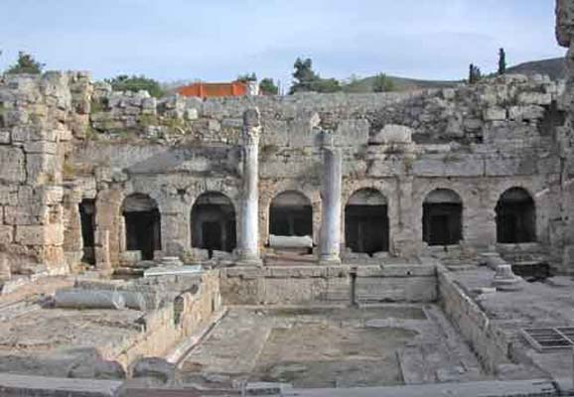

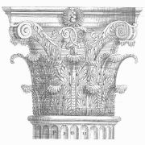

Paul is saying the divisions in Corinth are due to:

a) honest doctrinal disagreements.

b) different opinions on vital issues of the day.

c) spiritual immaturity.

**Four illustrations to teach the lesson.**

#1) The church is like a ______________ (vs. 5-9)

point 1:

point 2:

#2) The church is like a ______________ (vs. 10-11)

#3) The work of building will be _______________ (vs. 12-15)

by:

and by:

#4) The church is God’s ________________ (vs. 16-17)

**Lesson:**

How do I feel about this radical call? Am I willing?

New Covenant Presbyterian Church, PCA, Abingdon, MD (410) 569-0289**Studies in the Book of 1st Corinthians**

***God’s Wisdom to a Dysfunctional Church***

**Moron!**

*1 Corinthians 4:1-21*

(see also: Lk. 12:13-21; 2 Tim. 4:3; Heb. 9:27)

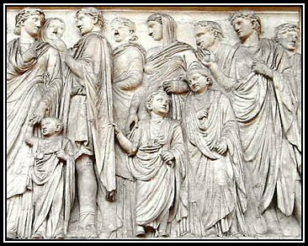

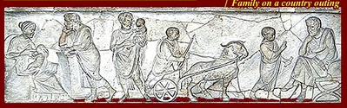

*Pater familias* means:

a) the father is in charge (until the mother disagrees).

b) the father is in charge (unless the children revolt).

c) the father is in charge.

The primary application to the lesson of chapter 3 is:

________________________.

(Vs. 8) Paul accuses them of being:

(Vs. 2) Instead, they should think of themselves as:

(Vs. 9) How will the world view you as a Christian?

How should we regard each other?

(Vs. 20-21) What real power does Paul want to exercise

toward the Christians in Corinth?

How does that power work in me?

New Covenant Presbyterian Church, PCA, Abingdon, MD (410) 569-0289

**Studies in the Book of 1st Corinthians**

***God’s Wisdom to a Dysfunctional Church***

**The Arrogance of Sexual Freedom**

*1 Corinthians 5:1-2*

(see also: Amos 2:7; Rom. 1:24, 26, 28; 1 Cor. 6:12, 18; Rev. 2:2-7)

To “live a Corinthian life”:

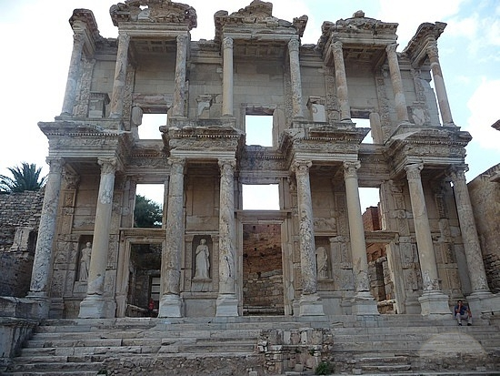

a) meant being respectable.

b) being flagrantly immoral.

c) not being very smart.

Pagan religions are,

in essence, ______________,

which is, inherently,

_________________.

Temple of Aphrodite, Ephesus

The Scriptures are the only place that teach you

that human sexuality

is _____________ & _________________

is reserved for the __________________ bond.

that you are not an _____________________.

Sexual conduct is part of the __________________

call of the gospel.

**Verse 1** – an immorality exceeding the pagans!

Why listen to Paul?

**Verse 2** – a rebuke exceeding compromise.

______________________ is an idolatrous attitude.

#1) We must mourn sexual sin.

It is a true _________________.

It brings true _________________.

It brings down the _____________ of Christ.

#2) We must remove the arrogant from the church.

What is your first love?

Why must the elders exercise church discipline?

What must we never forget?

Have I forgotten this?

New Covenant Presbyterian Church, PCA, Abingdon, MD (410) 569-0289**Studies in the Book of 1st Corinthians**

***God’s Wisdom to a Dysfunctional Church***

**When Discipline is Mercy**

*1 Corinthians 5:2b-8*

(see also: Ex. 12:15; Mt. 18:15-20; Rom. 12:1-2; 13:4; Heb. 11:8-10; 12:7-8; 13:17; 1 Pet. 2:9-10; 5:1-5)

Treatment of people during the Roman Empire:

a) was always gentle and encouraging.

b) was often idle and distracted.

c) was routinely brutal and heartless.

Paul teaches that obedience to God’s Word and dependence

on the gospel is the only __________ for mankind.

**1st Principle**: the law of God is our

_______________ ________________.

(choose one): The church is a democracy/monarchy.

#1: Paul’s authority:

#2: Procedure for church discipline:

**2nd Principle**: the ____________ of Christ’s name is first.

“deliver this man to Satan” means:

**3rd Principle**: Let the church maintain her __________________.

#1: “cleanse out the old leaven”

#2: “Celebrate the festival”

New Covenant Presbyterian Church, PCA, Abingdon, MD (410) 569-0289

**Studies in the Book of 1st Corinthians**

***God’s Wisdom to a Dysfunctional Church***

**Maintaining the Difference**

*1 Corinthians 5:9-13*

(see also: Judges 2:11-16; 21:P25)

How are we called to relate to the world?

a) to consider them our inferiors & ignore them.

b) to pity them from a distance.

c) to live the true, humble message of salvation before them.

**Principle #1: Compromise in the Church is not an option.**

What we face today is a loss of t____________.

May we compromise the gospel?

Isn’t Paul just being too opinionated here?

**II. Principle#2: To live before the world we must grow.**

**III. Principle #3: Relate to the world as the Lord leads.**

What does that mean for my witness?

New Covenant Presbyterian Church, PCA, Abingdon, MD (410) 569-0289**Studies in the Book of 1st Corinthians**

***God’s Wisdom to a Dysfunctional Church***

**Righteousness vs. the Law**

*1 Corinthians 6:1-11*

(see also: Ex. 18:21-22; Mt. 5:40; 15:19-20; Lk. 6:31; 1 Thess. 4:6; 2 Tim. 2:12; Heb. 1:14; 2:16; Jms. 2:8)

The Greek system of justice was:

a) democratic and intimidating.

b) calm, private and discreet.

c) always, always fair.

Paul’s primary concern here is:

**I. Christians are separated from the world.**

What are we to learn from the lack of details here?

To have lawsuits with one another is _______________.

Do real Christians ever find themselves in court?

**II. That separation must be clearly visible.**

“Do you not know” means:

Christians are different because we have been

washed -

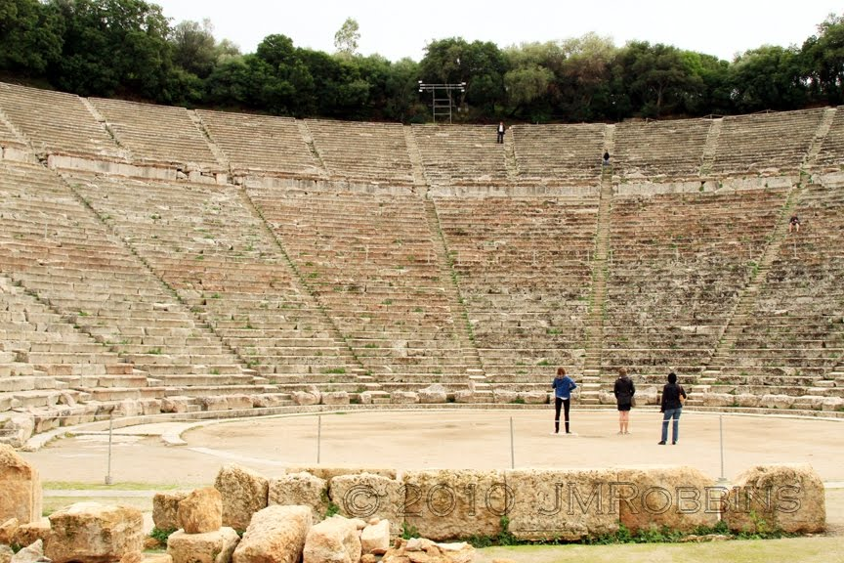

sanctified -

justified –

So, how should we

then live?

How should I then live?

New Covenant Presbyterian Church, PCA, Abingdon, MD (410) 569-0289

**Studies in the Book of 1st Corinthians**

***God’s Wisdom to a Dysfunctional Church***

**Another Look at Matthew 18**

*Mt. 18:15*

(see also: Mt. 5:38-42; 17:20; Mk. 11:22-23; Lk. 17:3-4; 1 Cor. 6:7;

1 Tim. 5:19; 1 Pet. 4:8)

When communication and accountability are done biblically

a) God is honored in such struggle and sacrifice.

b) lives are changed, friendships are restored.

c) the church is not needlessly segmented or splintered.

d) all of the above.

**I. What is my first responsibility?**

**II. Four Questions to Ask Myself.**

#1

#2

#3

#4

*“A new commandment I give to you, that you love one another: just as I have loved you, you also are to love one another. By this all people will know that you are my disciples, if you have love for one another.” (Jn. 13:34)*

New Covenant Presbyterian Church, PCA, Abingdon, MD (410) 569-0289**Studies in the Book of 1st Corinthians**

***God’s Wisdom to a Dysfunctional Church***

**You Are Not Your Own**

*1 Corinthians 6:12-19*

(see also: Gen. 4:7; 39:9, 12; Mt. 19:5; 1 Cor. 10:23; Eph. 5:23)

Demosthenes was:

a) a stand-up comedian in the city of Corinth.

b) a philosopher who said “all the world is a stage”.

c) a famous rhetorician and orator.

Only the truth of the Word of God ends the __________________

of women.

**Paul deals with two popular rationalizations:**

**#1: “All things are lawful for me.”**

________________’s Rule is how the moral law is applied to a Christian’s thinking/choices.

What would be an example to me of a socially-acceptable domination?

**#2: “Food for the stomach and the stomach for food.”**

1st: God’s law applies to your _____________.

2nd: You are not just body, you have a ____________.

What must I not do with the guilt of my sin?

What may I do with the conviction of my sin thanks to Christ?

New Covenant Presbyterian Church, PCA, Abingdon, MD (410) 569-0289

**Studies in the Book of 1st Corinthians**

***God’s Wisdom to a Dysfunctional Church***

**The Husband in Relation to His God**

Genesis 2:4-17

(see also: Gen. 5:1; 10:1; 11:10, 27; Mt. 19:4-5; Rom. 1:19-20; 5:12-21; 1 Cor. 11:7-9; 15:22, 47; Eph. 5:22-24; 1 Tim. 2:12-15)

The opening chapters of Genesis are a ____________ from God.

All creation was made with a _______________ character.

The Bible does not teach us the “how”,

it teaches us the “________”.

**Foundational Principles:**

1) Genesis uses the term ________ to describe

the human race (1:27).

Gen. 1:27-28 teach that man and woman are e___________

before God in terms of imagehood, value, rule and

responsibility in the world and the eternal inheritance

from God.

2) Gen. 2:7 teaches that it was by God’s deliberate purpose

that the man was made _____________,

and in Gen. 2:15-17 God establishes a r_______________

with the man.

Adam was the h________ of the first covenant,

C_________ is the head of the new covenant.

The husband represents Christ in the home in the roles of:

1)

2)

3)

Am I acting as Christ in my marriage?

New Covenant Presbyterian Church, PCA, Abingdon, MD (410) 569-0289**Studies in the Book of 1st Corinthians**

***God’s Wisdom to a Dysfunctional Church***

*Man in Relation to His Woman*

Genesis 2:18-25

(see also: 1 Chron. 12:22; Ps. 116:14, 18; 146:5; 2 Cor. 10:5)

Before we can decide whether to believe in evolution or agree with feminists we must:

What was the man’s first task (vs. 19-20)?

What was the Lord teaching the man by this?

What’s my application(s) in this?

What does the word “suitable” mean (vs. 21-22)?

What does the word “helper” mean?

Was the woman (like/different from) the man?

Why did God make *this* woman and not some other (vs. 23-25)?

What’s my application(s) to this?

What else was made that day besides the woman?

My wife’s soul belongs to _______________.

I must regard my marriage as ________________.

My marriage cannot be between two _________________ people,

so it must be the union of two ___________________________.

New Covenant Presbyterian Church, PCA, Abingdon, MD (410) 569-0289

**Studies in the Book of 1st Corinthians**

***God’s Wisdom to a Dysfunctional Church***

**The Weaker Vessel**

*1 Peter 3:1-7*

(see also: Gen. 12-23; Eph. 5:22-33; Col. 3:18-19)

Going from “suitable helper” to “weaker vessel”

a. sure doesn’t sound like the path to success today.

b. is actually quite complimentary in meaning.

c. is the reason so many women say the Bible is wrong.

d. all of the above.

**How does a wife act out her role as the “weaker vessel”?**

**I. Peter speaks of it in the wife’s attitude.**

What should a wife do

in an unequally yoked marriage?

in an equally yoked marriage?

What does Pastor Barker mean by “conscience”?

Young, unmarried ladies have control in 2 ways:

1) 2)

**II. Peter speaks of it in the wife’s character.**

What is really meant by Sarah’s calling Abraham “lord”?

Submission means

1)

What kind of power does “yes, but … “ have?

2)

What does “obedience” really speak of?

**III. Peter speaks of it in the wife’s loveliness.**

Sarah was a ______________ ________________.

Sarah was a ______________ ________________.

Sarah was not a ___________________ ________________.

This formula _____________ ________________.

But there 2 catches:

1.

2.

New Covenant Presbyterian Church, PCA, Abingdon, MD (410) 569-0289**Living and Growing in the Family of God**

**Marital Relationships: Abraham’s Sons**

*Ephesians 5:25-33*

(see also: Gen. 2:18f; Mt. 12:43-45; 1 Cor. 7:32-34; James 1:6-8;

1 Pet. 3:7)

Peter described the wife as the “weaker vessel” because

a) women are just not as strong as men.

b) women can’t take pressure or meet challenges as well as men.

c) wives, by God’s design, are exposed to the consequences

of their husband’s sins.

**I. Let’s review some basic, biblical principles.**

Genesis 2 -

Genesis 3 -

1 Peter 3 –

**II. The Gospel-Filled Answer in Ephesians 5.**

#1

#2

#3

New Covenant Presbyterian Church, PCA, Abingdon, MD (410) 569-0289

## B. B. and Annie Warfield

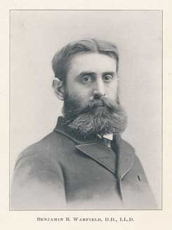

*Here are a couple of extracts about his marriage by K. Riddlebarger:*

Soon after marrying Annie Pearce Kinkead, who was also from noble stock, the newlyweds journeyed to Leipzig. . ..

During their stay in Europe an event occurred that would forever change the Warfield’s lives. While walking together in the Harz mountains, Mr. and Mrs. Warfield were caught in a violent thunderstorm. Annie Warfield suffered a severe trauma to her nervous system from which she never fully recovered. She was so severely traumatized that she would spend the rest of her life as an invalid of sorts, becoming increasingly more incapacitated as the years went by. Her husband was to spend the rest of their lives together giving her “his constant attention and care” until her death in 1915 (Allis, “Personal Impressions of Dr Warfield,” 10). B. B. Warfield could not have foreseen just how constant and difficult a demand this was to become, and how, in the providence of God, this would impact his entire career.

. . . Warfield’s remarkable literary output is, no doubt, in large measure due to the frail condition of his wife and his amazing devotion to her. With the pen he was a formidable foe, but as O. T. Allis recalls, “I used to see them walking together and the gentleness of his manner was striking proof of the loving care with which he surrounded her. They had no children. During the years spent at Princeton, he rarely if ever was absent for any length of time” (Allis, “Personal Impressions of Dr Warfield,” 10). Machen recalled that Mrs. Warfield was a brilliant woman and that Dr. Warfield would read to her several hours each day. Machen dimly recalled seeing Mrs. Warfield in her yard a number of years earlier during his own student days, but notes that she had been long since bed-ridden (Stonehouse, J. Gresham Machen, 220).

According to most accounts, Dr. Warfield almost never ventured away from her side for more than two hours at a time. In fact, he left the confines of Princeton only one time during a ten-year period, and that for a trip designed to alleviate his wife’s suffering which ultimately failed (Bamberg, “Our Image of Warfield Must Go,” 229). Though Warfield may have been known to many as a tenacious fighter, the compassion he directed toward his wife, Annie Kinkead Warfield, demonstrates a capacity for tenderness and caring that is in its own right quite remarkable.

In the mysterious providence of God, it was the nature of his wife’s illness and his devotion to her, that ironically provided the greatest impetus for his massive literary output. Personally vital and energetic, “he did not allow” his wife’s illness “to hinder him in his work. He was intensely active with voice and pen” (Allis, “Personal Impressions of Dr Warfield,” 11). Thus his creative energies were focused in two directions: his writing and the classroom. As caretaker for an invalid wife, Warfield spent many hours each day in the confines of his study.

Adaptation of ***1 Corinthians 13***

If ___________ speaks in the tongues of men and of angels, but has not love, ___________ is a noisy gong or a clanging cymbal. And if ___________ has prophetic powers, and understands all mysteries and all knowledge, and if ___________ has all faith, so as to remove mountains, but has not love, ___________ is nothing. **3**If ___________ gives away all he has, and if ___________ delivers up his body to be burned, but has not love, ___________ gains nothing.

___________ is patient and kind; ___________ does not envy or boast; ___________ is not arrogant or rude. ___________ does not insist on his own way; ___________ is not irritable or resentful; ___________ does not rejoice at wrongdoing, but rejoices with the truth. ___________ bears all things, believes all things, hopes all things, endures all things.

___________’s love never ends. As for prophecies, they will pass away; as for tongues, they will cease; as for knowledge, it will pass away. For ___________ knows in part and ___________ prophesies in part, but when the perfect comes, the partial will pass away. When ___________ was a child, he spoke like a child, he thought like a child, he reasoned like a child. When ___________ became a man, he gave up childish ways. For now ___________ sees in a mirror dimly, but then face to face. Now ___________ knows in part; then ___________ shall know fully, even as ___________ has been fully known.

So now faith, hope, and love abide, these three; but the greatest of these is ____________’s love for _________________.

**Studies in the Book of 1st Corinthians**

***God’s Wisdom to a Dysfunctional Church***

**“What’s He Really Saying?”**

*1 Corinthians 7:1-7*

(see also: Gen. 2:18; 39; Prov. 6:32; Eph. 5:22-33; 1 Thess. 4:3; Jms. 1:14-15)

Marriage in Western

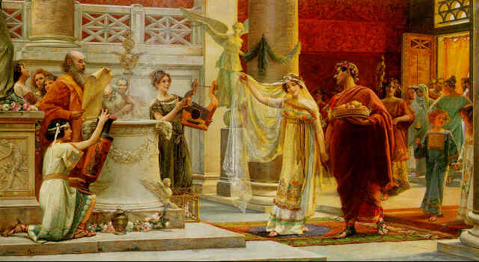

Civilization has often been:

a) made in heaven.

b) between two love-sick kids!

c) political entities.

How did the Christians in Corinth receive the teaching of Paul?

So what had caused the confusion regarding marriage?

As Paul writes this chapter, his language is:

Vs. 1:

What all does “touch” include?

Applications:

#1

#2

Vs. 2:

Where does immorality start?

Vs. 3:

What does “conjugal” mean?

Is the word “rights” appropriate here?

Instead of rights, marriage means you must pay your _________.

Your rights are something you must:

New Covenant Presbyterian Church, PCA, Abingdon, MD (410) 569-0289**Studies in the Book of 1st Corinthians**

***God’s Wisdom to a Dysfunctional Church***

**“BodyMates”**

*1 Corinthians 7:1-9*

(see also: Eph. 5:21)

The literature in ancient Greece

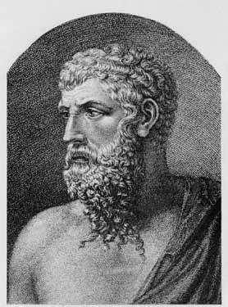

Aristophenes

a) is lost to us.

b) shows how different they were then we are today.

c) shows the same issues that we face today.

Paul’s view of marriage is radically

__________________.

Why is pre-marital counseling so important?

**Vs. 4 – Whose authority?**

1)

2)

3)

4)

5)

**Vs. 5 – Deprive or Defraud?**

**Vs. 6-9 - Whether unmarried or married, you must strive to be:**

New Covenant Presbyterian Church, PCA, Abingdon, MD (410) 569-0289

**Studies in the Book of 1st Corinthians**

***God’s Wisdom to a Dysfunctional Church***

**Hardness of Heart**

*Matthew 19:1-9*

(see also: Dt. 24:1-4; Eph. 5:22-33)

What was the test the Pharisees had in mind for Jesus?

a) They were all looking for “quickie” divorces.

b) They wanted to pin a political label on him.

c) They were all training to be lawyers.

The Pharisees thought they understood ________________

because they studied _________________.

True or False: My vows, whatever the circumstance, are just

formalities and mean nothing.

Divorce is ____________ because marriage

is _________________.

**Jesus’ answer to the Pharisees:**

Step 1: The 1st fundamental principle in marriage

is ___________

True or False: Joking about “getting a divorce” to your spouse is

harmless and funny.

Step 2: The 2nd fundamental principle is that marriage is

_______________________ and _____________________.

Step 3: The 3rd fundamental principle in marriage is

“God ordained my _____________________ and hates

____________________.”

In what ways have I grown hard-hearted toward my spouse?

Is Christ able to deal with hard-heartedness in my marriage?

New Covenant Presbyterian Church, PCA, Abingdon, MD (410) 569-0289**Studies in the Book of 1st Corinthians**

***God’s Wisdom to a Dysfunctional Church***

**Grounds for Biblical Divorce**

*Matthew 5:31-37*

(see also: Dt. 24:1-4; Jer. 3:8; Hos. 1-2; Mk. 10:2-12; Lk. 16:18; 1 Cor. 7:4, 10, 12)

The Bible’s teaching on divorce can be found in:

a) Deuteronomy 24.

b) the gospels

c) 1 Corinthians 7

d) all the above.

Physical unfaithfulness is the 1st _________________ for divorce.

**I. Jesus’ Words in the Gospels**

Parallels:

Mt. 5 is paralleled with ____________________.

Mt. 19 is paralleled with _____________________.

II. The Larger Lesson Regarding Divorce

Mt. 5:32

(Choose one): This is a lesson in marital

(headship/equality).

Mk. 10:10-12

(Choose one): This is a lesson in marital

(headship/equality).

III. The Preaching of Hosea

*Jezreel* –

*Lo-ruhama* –

*Lo-ammi* –

In Christ, God has restored/redeemed us as his ______________.

New Covenant Presbyterian Church, PCA, Abingdon, MD (410) 569-0289

**Studies in the Book of 1st Corinthians**

***God’s Wisdom to a Dysfunctional Church***

**Christian Separation and Divorce**

*1 Corinthians 7:10-16*

(see also: 1 Sam. 16:7; Mt. 7:16; 2 Cor. 6:14; Eph. 5:22-33; Heb. 13:7, 17)

Euripides was a 5th c BC playwright



*Madea* by Sandys

a) who wrote sit-coms.

b) who wrote books about demons.

c) who wrote tragedies like *Medea*.

An “unequally yoked” marriage is:

**I. Divorce between a believer and**

**unbeliever (vs. 12-13).**

Paul says stay in such a marriage because:

#1

#2

#3

Paul says the 2nd ground for permissible divorce is:

**II. Questions:**

#1: who decides?

#2: what is “separation”?

**III. Divorce between believers (vs. 10-11)**

What does a Christian marriage have than an unequally yoked marriage does not have?

Is Paul’s directive to “remain unmarried” to be barring for life?

To whom must Christians turn at these times?

Who is really responsible for the health of your marriage?

New Covenant Presbyterian Church, PCA, Abingdon, MD (410) 569-0289**Studies in the Book of 1st Corinthians**

***God’s Wisdom to a Dysfunctional Church***

**Family Holiness**

*1 Corinthians 7:14*

(see also: Dt. 22:10; 2 Cor. 6:14-7:1)

The section of Scripture we have been studying is on:

a) salt and pepper.

b) marriage and divorce.

c) meat and potatoes.

More than anything else, this verse is here to ________________

the believing spouse in an unequally yoked marriage.

**I. Compare this with 2 Cor. 6.**

God’s laws are always given us for our _______________.

What do a believer and an unbeliever really have in common?

What must the Christian do: *“touch no _____________ thing.”*

**II. Now to 1 Cor. 7.**

(choose) A single believing person (should/should not)

marry an unbeliever.

(choose) A married person who becomes converted

(should/should not) divorce the unbelieving spouse.

Verse 14:

1) holy –

2) unclean –

Paul encourages the believer by saying:

**III. A Covenantal Conclusion**

While this one verse does not _________ that the covenant

promises of God are to believers and to their children,

this verse simply cannot be _____________________ without

it.

Do I sense the encouragement that I receive from God due to his promises?

New Covenant Presbyterian Church, PCA, Abingdon, MD (410) 569-0289

**Studies in the Book of 1st Corinthians**

***God’s Wisdom to a Dysfunctional Church***

**The Focus of the Christian Life**

*1 Corinthians 7:17-24*

(see also: Ps. 73; Mt. 28:18-20; Col. 2:11-12)

The Epic of Gilgamesh teaches

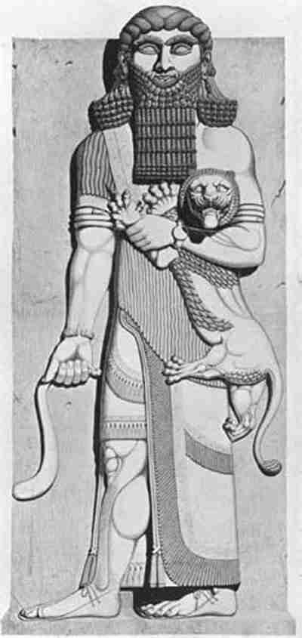

a) the meaning of life is in hard work.

b) “eat, drink & be merry”.

c) that the flood never happened.

Why is “hedonism” so hard to practice?

I. The Christian calling is an

indescribable _________.

Why does circumcision or uncircumcision mean nothing

today?

In what ways have I hid my Christian faith in public?

II. Your calling, as a Christian calls for a greater and greater

sense of _________________.

Why is envy and jealousy such a sin?

Paul uses slavery to men as an example of a Christian’s

slavery to ____________.

What must I do when I envy the wicked?

New Covenant Presbyterian Church, PCA, Abingdon, MD (410) 569-0289**Studies in the Book of 1st Corinthians**

***God’s Wisdom to a Dysfunctional Church***

**Balancing Gifts and Priorities**

*1 Corinthians 7:25-35*

(see also: Mt. 22:30; Lk. 6:29b-30; Rom. 8:20-22; 2 Cor. 6:10;

1 Jn. 2:17a)

If you lived in ancient Greece & felt threatened, you would

a) call 911.

b) just depend on the national government to take care of you.

c) fight for your life alongside your neighbors.

I. The greatest opportunity we live for is to:

II. Each calling in life has its own

___________________ & ______________________.

New Covenant Presbyterian Church, PCA, Abingdon, MD (410) 569-0289

**Studies in the Book of 1st Corinthians**

***God’s Wisdom to a Dysfunctional Church***

**Last Thoughts On Marriage**

*1 Corinthians 7:36-40*

(see also: Prov. 3; 31; 1 Cor. 7; Eph. 5:22-33; 1 Tim. 5)

One reason Paul must teach on marriage so clearly is:

a) the world around us is so very unbiblical.

b) our own impulses/reasoning can lead us astray.

c) we all need to know the directions/blessings God has for us.

d) all of the above.

**Two more categories to consider here:**

**I. Young men (vs. 36-38)**

Why is dating a bad idea?

God’s word gives you both:

curbs –

wisdom –

A young Christian man needs

a _____________ _____________________________.

Entering into a relationship, a young man must not:

a)

b)

**II. Young widows (vs. 39-40)**

The best way to honor the memory of your marriage is to:

She should be

grateful –

productive –

celebratory -

She must remember her body belongs to the Lord.

New Covenant Presbyterian Church, PCA, Abingdon, MD (410) 569-0289**Studies in the Book of 1st Corinthians**

***God’s Wisdom to a Dysfunctional Church***

**Christian Peer Pressure**

*1 Corinthians 8:1-13*

(see also: Ex. 20:4-5a; Prov. 1:7; 3:5)

Greek Mythology

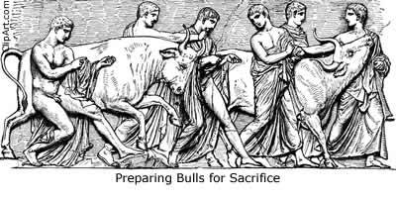

a) started after the time of

Christ.

b) was created in the modern

world to explain Greek

lifestyle.

c) began almost a millennium

before Christ.

(Choose one) The gospel (conflicted with/was compatible with) Greek mythology.

“Our hearts are __________________ _____________________.”

(John Calvin)

**I. What is Idol-Worship?**

Idols are not __________,

but idolatry has corruptive _____________:

a)

b)

c)

d)

**II. What to do with Knowledge?**

What does Paul mean by “weak”?

1)

2)

Who is Paul speaking to here?

New Covenant Presbyterian Church, PCA, Abingdon, MD (410) 569-0289

**Studies in the Book of 1st Corinthians**

***God’s Wisdom to a Dysfunctional Church***

**A Worthy Spiritual Hire**

*1 Corinthians 9:1-12a*

(see also: Rom. 10:14-15; Phil. 2:4-8; 1 Tim. 4:12; 5:17-22)

When Paul was in Corinth

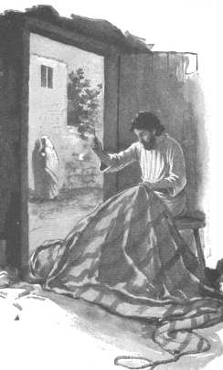

The Tentmaker

a) he made tents to provide for himself.

b) he imposed himself upon the

congregation.

c) he lived off food-stamps.

I. The church’s obligation

is to support her ___________________.

A. Apostles -

B. Elders –

II. What is involved in this support?

Is there an objective standard?

Basic principles:

#1 Cover the essentials.

a.

b.

c.

Can the ministry be compared to other careers?

Similarities –

Differences

Both the minister and the congregation are calle

to make ________________________.

New Covenant Presbyterian Church, PCA, Abingdon, MD (410) 569-0289**Studies in the Book of 1st Corinthians**

***God’s Wisdom to a Dysfunctional Church***

**An Unblemished Reputation**

*1 Corinthians 9:11-18*

(see also: Dt. 18:1-8; Mt. 10:5-10; Lk. 10:1-7; Acts 4:13-20; 18:1-4; Rom. 15:25-27; 2 Cor. 11:7-11; Phil. 4:14-20; Gal. 6:6)

The first two questions this chapter asks are:

a) what time is it and where are we?

b) why must we sit thru another sermon & how long will this one be?

c) is the church obliged to her minister and to what extent?

**Two more questions asked here:**

**I. What is the nature/need for the visible church?**

What do we mean

by “invisible”

by “visible”

Which is the more important?

What foundational principles support the visible church?

#1

#2

**II. How valuable/important is the visible church?**

How has the church in Corinth been blessed?

But how has this blessing turned into a problem?

What should a minister do under such strife?

#1

#2

What he must not do:

How is the minister to be Christlike?

New Covenant Presbyterian Church, PCA, Abingdon, MD (410) 569-0289

**Principles Related to the Tithe**

* Believers are called of God to set aside a full tithe (10%) of their income to present to the Lord for the service of His work. For some this may be a new idea and if that includes you, it could well be that your current budget cannot immediately absorb this. If so, what you should do is start where you can, even if it only 1%. You should not think to postpone this until you can give a whole tithe because that day will then never come. Practice the principle now that you will not worship God empty-handed. Then, commit yourself in future years to a stair-step schedule of increasing to a level of the tithe as your budget can be adjusted and as you are blessed over the next several years with increase.
* Christians who commit themselves to the visible body – that is, become communicant members of the local church – should understand that their duty to give the full tithe to the congregation of which they are members. If you wish to support other ministries and/or causes as well, that should not come out of the tithe but be given over and above it as sacrificial giving. This way the church does not suffer for the sake of other interests.
* Even though you may have favorite departments or ministries within the church that you would like to specifically support, the rule of thumb you should normally go by is to make your support to the church in an undesignated fashion. This reminds you of the need to support the entire church and her needs but it also expresses a trust that the elders are in charge of and responsible for the direction of the church as a whole and that the deacons are faithful with the disbursement of monies toward those goals.
* We do not use pledge cards in order to plan for budgetary expenditures because we realize that each giving individual or family is subject to changes in prosperity during the year. One may lose a job for months, another gets a substantial raise. The principle of the tithe is based on income, not on promises. The elders track income and spending from years past and very cautiously project necessary increases in future months. Living by faith does not allow us to presume on God.

**Studies in the Book of 1st Corinthians**

***God’s Wisdom to a Dysfunctional Church***

**The Personal Roadblock**

*1 Corinthians 9:19-27*

(see also: Mt. 20:20-28; Phil. 2:1-11; 3:1-12; Heb. 12:1-4)

Running a race

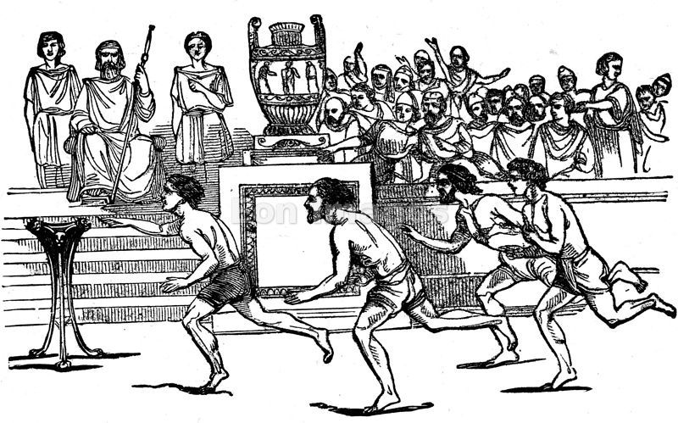

a) should be politically correct –

everyone should be a winner.

b) is too much like work.

c) rewards the earnest.

**I. How Paul states his goal (vs. 19-23).**

Christian liberty is not:

Antinomianism -

Christian license –

Christian liberty is:

**II. How Paul aims to achieve his goal. (vs. 24-27)**

Paul is not:

Rather, he is:

“Man is most free when ____________________ by God alone.”

Augustine

New Covenant Presbyterian Church, PCA, Abingdon, MD (410) 569-0289

**Studies in the Book of 1st Corinthians**

***God’s Wisdom to a Dysfunctional Church***

**Remembering Our Fathers**

*1 Corinthians 10:1-5*

(see also: Ex. 13:17-22; 14; 16; 17:1-7; Ps. 18:31; 78:15-16;

Gal. 3:29; Heb. 9:15)

1 Cor. 8-11 is a section dealing with:

a) how Christians are to function as part of the visible church.

b) how Christians are to understand their liberty in Christ.

c) how Christians are to live their lives to honor Christ.

d) all of the above.

Review:

**I. The Corinthian Christians need to know**

**of God’s work in the past.**

“brothers” –

“our fathers” –

**II. What is it Paul wants these Christians to understand?**

Five activities:

“under the cloud” –

“passed through the sea” –

“baptized into Moses in the cloud and sea” –

“at the same spiritual food” –

“drank the same spiritual drink” –

Three emphases:

“all” -

“baptism” –

“the same food and drink” –

III. Three Observations

#1

#2

#3

New Covenant Presbyterian Church, PCA, Abingdon, MD (410) 569-0289**Studies in the Book of 1st Corinthians**

***God’s Wisdom to a Dysfunctional Church***

**The Way of Escape**

*1 Corinthians 10:1-13*

(see also: Ex. 32; Jer. 17:9; 2 Cor. 12:10; Heb. 11:1-2; )

Ancient Corinth was

a) a wholesome, mild-mannered, responsible city.

b) an intellectual powerhouse of engineering and the arts.

c) a cesspool.

Pagan religion is

#1:

#2:

**I. Paul continues to connect the past to the present.**

This passage teaches the essential _______________

of the covenant.

**II. The main point on Paul’s mind here (vs. 7-8)**

The Golden Calf was made

out of their own _________________________

& out of their desire to worship as they _______________.

What did Moses mean by “play”?

What do you learn ONLY from the Bible?

III. Be encouraged! Your call and challenge as a Christian

is to ___________ God’s word & ____________ your heart.

is to ______________ God for the word he gives you.

is to ____________ God for what his word calls you.

You will feel trapped when you:

You will always find escape when you:

New Covenant Presbyterian Church, PCA, Abingdon, MD (410) 569-0289

**Studies in the Book of 1st Corinthians**

***God’s Wisdom to a Dysfunctional Church***

**Participants with Christ**

*1 Corinthians 10:14-22*

(see also: Ex. 20:4-6; 2 Kings 5; Is. 55:5-7; Mt. 6:23-25; Heb. 10:31)

The biggest idol of our day and age is:

a) “American Idol”

b) Idleness

c) Mankind

**I. Christian _______________ is being freed from idolatry.**

We are called to live as Christ’s ________________________.

This speaks directly to our ___________________.

**II. How do you “flee” from idolatry?**

Naaman –

Solomon –

An attitude of _________________ and ____________________

will prevent you from idolatry.

**III. Living in the World for Christ.**

#1

This teaches us about the Lord’s Supper:

only __________________ should partake,

it should always be observed __________________.

#2

Your enemies are ________________

and his ______________.

#3

#4

The 2nd commandment comes with

great __________________ and ____________.

New Covenant Presbyterian Church, PCA, Abingdon, MD (410) 569-0289**Studies in the Book of 1st Corinthians**

***God’s Wisdom to a Dysfunctional Church***

**Christian Peer Pressure (continued)**

*1 Corinthians 10:23-11:1*

(see also: Ex. 20; Prov. 27:17; 31:25; Ps. 104:14-15; Jn. 17:14-19; Rom. 3:31; 6:1; 12:1-2; 1 Jn. 2:16; )

Christians must be:

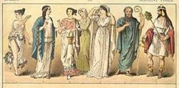

a) of the world but not by the world.

b) in the world but not as the world.

c) in the world but not of the world.

**I. The Principle of Christian Liberty**

It is not:

or:

In order to be helpful, you must have:

In order to build up, you must:

**II. Two points regarding making choices.**

#1

#2

**III. Conclusion of entire section.**

A Charge -

A Reminder –

An Example -

New Covenant Presbyterian Church, PCA, Abingdon, MD (410) 569-0289

**Studies in the Book of 1st Corinthians**

***God’s Wisdom to a Dysfunctional Church***

**The Biblical Principle of Headship**

*1 Corinthians 11:2-3*

(see also: Gen. 1:26-28; 2:7, 15-25; 17:7; Eph. 5:22-33; 1 Pet. 3:1-7; Rev. 21:7)

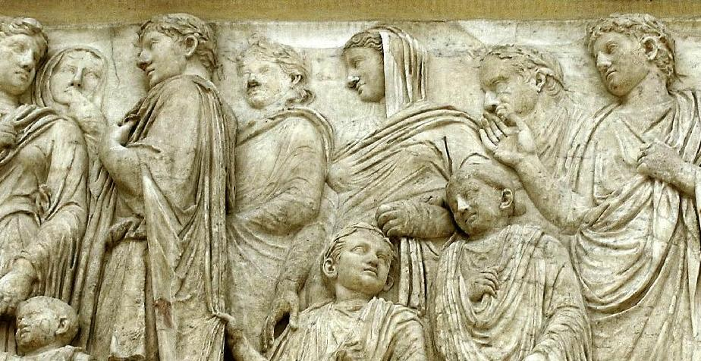

“Dysfunctional” means:

a) working as a model to others.

b) not functioning at all.

c) not functioning as designed.

Chapters 1-10 dealt with social issues within the church such as:

Chapters 11-14 & part of 16 deal with issues related to:

**I. What does Paul mean by the word “head”?**

literally:

metaphorically:

source/origin -

authority –

II. How is biblical headship twisted today?

by chauvinist men -

by feminist women –

Does the rest of the Bible teach headship?

**III. The Biblical Formula for Headship**

Principle #1:

Principle #2:

New Covenant Presbyterian Church, PCA, Abingdon, MD (410) 569-0289**Studies in the Book of 1st Corinthians**

***God’s Wisdom to a Dysfunctional Church***

**The Glory of Man and Woman**

*1 Corinthians 11:2-16*

(see also: Gen. 1-2; 1 Cor. 14:34f; 1 Tim. 2:8ff; 1 Pet. 3:1-7)

Which is true?

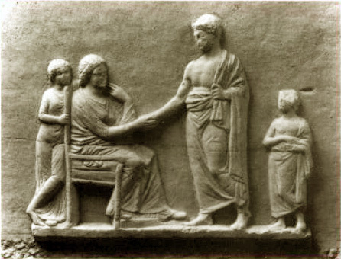

a) Someone besides Paul added these words.

b) Paul was only speaking to his own culture.

c) Paul had some specific women in that church in mind.

d) Paul wants the Church of Christ to be led by the principle of headship.

**Verse 3**

head:

man/husband & woman/wife:

**Verse 4**

All of life is to be lived _______________ ____________

What is prophecy?

Is all prophecy the same?

Covering of the head

Literal -

Metaphorical –

**Verse 15 – According to Nature**

Ring #1 -

Ring #2 –

Ring #3 -

Ring #4 -

New Covenant Presbyterian Church, PCA, Abingdon, MD (410) 569-0289

**Studies in the Book of 1st Corinthians**

***God’s Wisdom to a Dysfunctional Church***

**A Proper Meal**

*1 Corinthians 11:17-34*

(see also: Jer. 31:31-34; Mt. 26:26-28; Mk. 14:22-24; Lk. 22:19-20; Jn. 6:25-71)

Paul is giving us in ch.s 11-14:



a) a full directory for worship.

b) a clear indication of what is most important in worship.

c) what the Corinthians were doing wrong in worship.

**I. What were these guys doing?**

(vs. 20-22, 33-34)

So was that the Lord’s Supper?

**II. Paul’s instruction**

A. Where does Paul’s teaching come from (vs. 23)?

B. What does he mean by “the new covenant” (vs. 25)?

C. What does Jeremiah mean by “new covenant” (Jer. 31:31)?

D. The “new” doesn’t mean “substance” but _____________.

New Covenant Presbyterian Church, PCA, Abingdon, MD (410) 569-0289**Studies in the Book of 1st Corinthians**

***God’s Wisdom to a Dysfunctional Church***

**Informing the Uninformed**

*1 Corinthians 12:1-3*

(see also: Jn. 3:16; Acts 4:12; 1 Cor. 15:3b-5)

Paul had so much to teach the Corinthian Church because:

a) they were doing everything right.

b) they were such good theological students.

c) much of what they were doing as a church was wrong.

**I. Paul starts this section off by focusing on**

_________________________ truths.

How is propositional truth regarded in our culture?

Christians need to understand how their worship of God

differs from the worship of:

**II. What phenomenon actually works against us here?**

__________________/______________ tend to divide

while ________________/_________________ tend to unite.

Still, what does Paul want us to trust in more?

**III. Three things we want to keep in mind.**

#1

#2

#3

New Covenant Presbyterian Church, PCA, Abingdon, MD (410) 569-0289

**Studies in the Book of 1st Corinthians**

***God’s Wisdom to a Dysfunctional Church***

**For the Common Good**

*1 Corinthians 12:4-13 –* ***Not Recorded***

(see also: the Gifts Chart; Acts 8:19)

In vs.s 1-3, Paul wants the Christians in Corinth

a) to feel their way along.

b) to consider truth just whatever they decide it to be.

c) to be informed and to understand.

**In vs.s 4-13, Paul speaks of:**

**I. The Variety of the Gifts.**

*Pneumatikos* and *Charismata* refer to:

(Pick two): The list of gifts in 1 Cor. 12

a) is the one, official & complete list.

b) one of many lists in the New Testament.

c) the gifts the Corinthians seem to have trouble handling.

**II. The Unity of the source and Identity of the Recipients**

What gifts are listed here to protect the Corinthians from mistake?

Why is the doctrine of the Church important here?

**III. The Different Purpose of the Gifts.**

Perspective #1:

Perspective #2:

Which perspective is indicated by the lists of gifts in the New Testament?

New Covenant Presbyterian Church, PCA, Abingdon, MD (410) 569-0289**Studies in the Book of 1st Corinthians**

***God’s Wisdom to a Dysfunctional Church***

**The Body**

*1 Corinthians 12:11-26*

Review:

Vs.s 1-3 – regard ________________ and __________________

over emotion and experience.

Vs.s 4-10 – (choose one) the other lists of gifts from God in

the NT are (different/the same) as the ones we find

in 1 Corinthians.

In 1 Cor. 12:11-31, a section of twenty verses we find:

a) a highly complex series of instructions/guidelines for the church.

b) a long list of choices that each member of the church may pick and choose from.

c) one simple message for all.

**I. Paul reviews points already made.**

Vs. 11 – the gifts are given the church by

the ___________________ will of God.

But just because the gifts

are given i________________________

doesn’t mean they are given i________________________.

Vs. 12-13 – No undue symbolism here.

The main point: all Christians share in the u__________

that is the church.

**II. Vs. 14-24: What is Paul really saying here?**

(choose one) Paul is writing a (how-to manual/correction)

to the thinking of the Corinthians.

Vs. 14 –

Vs. 15-16 -

Vs. 21 –

Vs. 22-25 -

III. Summing up his thoughts, Paul says

#1:

#2:

#3:

How do I strengthen the church with the gifts God has given me?

New Covenant Presbyterian Church, PCA, Abingdon, MD (410) 569-0289

**Studies in the Book of 1st Corinthians**

***God’s Wisdom to a Dysfunctional Church***

**The Higher Gifts**

*1 Corinthians 12:27-31*

(see also: 1 Cor. 1:2; 12:8-10; Eph. 2:20; Heb. 5:4)

The bottom line to Paul’s argument in vs. 11-26 is:

a) Paul is calling for a radical correction in their thinking.

b) Paul is affirming all they have concluded so far.

c) Paul is learning from the Corinthians how to understand all this.

**I. The Essential Point: “______ are the body of Christ …”**

In the church, there are to be no “_____________” and

“____________ _______”.

Instead, he wants them all to be _________________.

**II. Paul offers another list (vs. 28).**

1st:

2nd:

**III. Paul speaks against “gift envy” (vs. 29-30).**

1st:

2nd:

**IV. “Earnestly desire the __________________ gifts.” (vs. 31)**

How do we determine what those are?

Would most of these gifts be for the life of the church?

How am I appreciating such gifts in my church?

New Covenant Presbyterian Church, PCA, Abingdon, MD (410) 569-0289**Studies in the Book of 1st Corinthians**

***God’s Wisdom to a Dysfunctional Church***

**The Priority of Love**

*1 Corinthians 12:31b-13:3*

(see also: Ps. 19:7-8; Mt. 25:14-30; Mk. 10:17-31; Phil. 2:6-8; Jude 3; Rev. 22:18-19)

The one Scripture passage most often heard at weddings is:

a) Jn. 3:16

b) Psalm 23

c) 1 Cor. 13

**I. The Vocabulary of This Chapter**

Greek words for “love”:

*phileo* –

*eros* –

*agape* –

The one used consistently throughout this chapter is

_________________.

The closest analogy in Scripture to this kind of love is

__________________.

**II. The Requirement of Love**

Vs. 1 –

Is there any other book of the Bible that speaks of Paul as a “tongue-talker”?

Does the Bible speak of an “angelic language”?

Vs. 2 –

Vs. 3 –

If the rich young man had done what Jesus asked, would he had been better off?

**III. Love as More than a Priority**

Love is really a ___________________.

The only way to receive this chapter is by ______________.

My 1st real priority is:

My 2nd real priority is:

May 3rd real priority is:

New Covenant Presbyterian Church, PCA, Abingdon, MD (410) 569-0289

**Studies in the Book of 1st Corinthians**

***God’s Wisdom to a Dysfunctional Church***

**The Character of Love**

*1 Corinthians 13:4-8a*

(see also: Mt. 18:23-35; 1 Pet. 4:8)

When Paul speaks here of *agape* love

a) he confines it to the authority of God and his Moral law.

b) he just wants us all to get along and stop fighting.

c) he wants each of us to think about how we would define love

and what it means to each one of us.

What is this “more excellent way”?

a) It is just Paul’s attempt at warm and fuzzy poetry.

b) It is the way of love that reveals the character of God.

c) It is Paul’s trying to assert his own will on how he thinks

the church should be.

**I. Love is _____________________ and ___________________.**

That means that love is not envy, boast, arrogant, rude, does not insist on its own way, is not irritable or resentful because:

it does not rejoice in ________________________________

but rejoices in God’s ___________________.

**II. Love is _________________________.**

How would righteous anger apply here?

How would 1 Peter 4:8 apply here?

**III. Love is _______________________.**

Do I trust in the love of God? Do I act that out in my life?

New Covenant Presbyterian Church, PCA, Abingdon, MD (410) 569-0289**Studies in the Book of 1st Corinthians**

***God’s Wisdom to a Dysfunctional Church***

**The Nature of Love**

*1 Corinthians 13:8-13 –* ***Not Recorded***

(see also: Mt. 22:37-40)

At the end of ch. 13, Paul turns his attention for the first time

a) to what he wants to eat for dinner.

b) not just to day-to-day affairs but to the glory to come.

c) to introducing yet more spiritual gifts to the church.

**The Nature of *Agape* Love**

**I. Why is this so important a contrast for Paul here?**

Love Prophecies, Tongues, Knowledge

What is it we must agree on here?

In order to do that, what must the church do?

**II. What does it mean that prophecies, tongues & knowledge**

**will pass away?**

Are we sure, yet, what these words really mean?

Are we sure when all three will terminate?

Our knowledge will pass away because what we have

now is:

Perfect knowledge means:

**III. Abiding with the Partial.**

Do I exercise my faith, hope and love in the church?

New Covenant Presbyterian Church, PCA, Abingdon, MD (410) 569-0289

**Studies in the Book of 1st Corinthians**

***God’s Wisdom to a Dysfunctional Church***

**The Value of Prophecy**

*1 Corinthians 14:1-5*

**Studies in the Book of 1st Corinthians**

***God’s Wisdom to a Dysfunctional Church***

**Signs of the Spirit**

*Acts. 2:1-4; 1 Corinthians 14*

(see also: Gen. 1, 2; 1 Kg.s 19:9-13; Lk. 3:16f; Jn. 3:3, 5, 8; Heb. 12:29)

How are we to understand Pentecost?

**I. The Experience: being “filled with the Holy Spirit”**

Sign #1: “A _______________ like a mighty rushing wind”

Heb.: “ruach”

Gk.: “pneuma”

Sign #2: “And divided tongues ______ _______ fire”

Why were these signs so tangible and visible?

Was the Holy Spirit in the wind and fire?

Where should your attention be?

**II. The Meaning: “being filled with the Holy Spirit”**

1st Meaning:

1.

2.

3.

2nd Meaning:

(Choose one) Christ’s giving of the Holy Spirit to the entire

church was a unique/common event.

Should Christians today seek this kind of Pentecost experience

for themselves?

In what ways might I be denying the filling of the Holy Spirit in

my own life?

New Covenant Presbyterian Church, PCA, Abingdon, MD (410) 569-0289**Studies in the Book of 1st Corinthians**

***God’s Wisdom to a Dysfunctional Church***

**A Voice of Praise**

*Acts. 2:5-21*

(see also: Gen. 11; Mt. 3:11; Acts 1:5; 1 Cor. 12:13)

Along with the outward signs of the Spirit at Pentecost of

the sound of the wind & tongues as of fire

was “other ______________________”.

**I. But first: why were there any signs at all?**

Is it normal for the indwelling of the HS to have such signs?

The major reason for it here must be:

which explains why it is referred to here as the

______________ of the Holy Spirit (1:5).

The only place an event is described in Scripture as the

“baptism with the Holy Spirit” is ____________________.

Is “baptism with the Holy Spirit” the same

as “filled” with the Holy Spirit?

**II. The sign of Tongues**

What are the “other tongues” Luke describes here in Acts 2?

The other tongues in Acts 2 did not result

in c_________________

but in c_________________________.

What purpose did the miracle of tongues serve the disciples at Pentecost?

In what language did Peter most likely preach his sermon?

**III. What about tongues for today?**

A. They represent the _____________ of God for the church.

B. But they are not the ___________ God provides for

the church.

New Covenant Presbyterian Church, PCA, Abingdon, MD (410) 569-0289**Studies in the Book of 1st Corinthians**

***God’s Wisdom to a Dysfunctional Church***

**What Are You Saying?**

*1 Corinthians 14:1-19*

(see also: Gen. 11; Mt. 6:7-8; Acts 2; 1 Cor. 13:13)

The lessons from Acts 2 included:

a) the uniqueness, communication, attention, and temporary nature of the gift.

b) the commonality, confusion, distraction, and permanence of the gift.

c) the uniqueness, confusion, attention, and permanence of the gift.

**I. Vs. 1-5: Pursue love and pursue prophecy.**

What is most likely the meaning of desiring prophecy?

How does Paul describe the Corinthian version of tongues?

vs. 2 -

vs. 4 –

Should we just assume the Corinthian version is correct also?

**II. Vs. 6-12: Paul’s Rhetorical Critique**

As to Priority

vs. 6 -

vs. 7 -

vs. 8 -

vs. 9 –

vs.s 10-11 –

vs. 12 –

As to Form

vs. 13-15 –

vs. 16 –

**III. Paul’s Surprising Admission**

What kind of tongues is he talking about here?

What should matter more to me – experience or teaching?

New Covenant Presbyterian Church, PCA, Abingdon, MD (410) 569-0289**Studies in the Book of 1st Corinthians**

***God’s Wisdom to a Dysfunctional Church***

**Decently and in Order**

*1 Corinthians 14:20-40*

(see also: Is. 28:11-12; Acts 2; 1 Cor. 11:2-16; 12-13)

The longest section of Paul’s corrective teaching in 1 Cor. is:

a) regarding immoral practices within the church.

b) the proper observance of the Lord’s Supper.

c) the controversy over the gifts of the Spirit.

**I. The Proper Understanding of Tongues (vs. 20-25)**

They are a sign for:

But conversion will come through:

**II. The Proper Practices in Worship (26-33a)**

The over-all goal is:

If a tongue is spoken

#1

#2

#3

**III. The Gifts and a Woman’s Role in Worship**

Is this a universal prohibition or a localized one?

What is the “shame” Paul speaks of here?

Is this an absolute prohibition or a specific one?

What can be learned from the historic Pentecostal experience in the United States?

What is my role before God?

Am I willing to do it “decently” and “in order”?

New Covenant Presbyterian Church, PCA, Abingdon, MD (410) 569-0289**Studies in the Book of 1st Corinthians**

***God’s Wisdom to a Dysfunctional Church***

**Appendix: Apostolic Signs & Wonders**

*Acts. 3:1-10; rf. 1 Cor. 12:7-11*

(see also: Is. 35:6; Mt. 2:1-12; Jn. 9; Acts 2:43; 4:5; 2 Cor. 8:9)

What occurred (Acts 3-5) as the result of: “many wonders and signs were being done through the apostles” (Acts 2:43)?

**I. Why is this act recorded here?**

What day is this most likely to have been?

Other reasons:

**II. What is this act?**

**III. What does this act mean to us?**

A.

B.

C.

New Covenant Presbyterian Church, PCA, Abingdon, MD (410) 569-0289**Studies in the Book of 1st Corinthians**

***God’s Wisdom to a Dysfunctional Church***

**Mere Resurrection**

1 Corinthians 15:1-11

(see also: Num. 32:23; Jn. 3; 1 Cor. 15:19; WSC #31, 32, 37)

**The Bible** is

a) a singularly composed effort at religious propaganda.

b) is a compilation of 66 books & letters written over 2500 years.

c) something I haven’t read in ages.

(True/False) 1st Corinthians was written within 20 years of the time of Christ.

“Gospel” can be translated to mean _________ _________.

The essence of the gospel for Paul is Christ __________________.

Paul’s List here includes:

1)

2)

3)

4)

**Two basic principles about the good news:**

1) (Choose one) The resurrection is historical/mythological.

How can we know (rf. Num. 32:23)?

It is unbelief that is not _______________ or ________________.

2) Unbelief is not only a ________________ of God,

it is _______________ against God

because it rejects the gift of ______________.

How is salvation more than just being convinced?

What list is better than Paul’s here in 1 Cor. 15?

New Covenant Presbyterian Church, PCA, Abingdon, MD (410) 569-0289**Studies in the Book of 1st Corinthians**

***God’s Wisdom to a Dysfunctional Church***

**What Difference Does It Really Make?**

*1 Corinthians 15:12-19*

(see also: Gen. 3:15; Ps. 23; Heb. 9:27; 10:31; Rev. 2:11; 20:6, 14; 21:8; WCF, ch. 32; WSC #37)

While God does not spare Christians from physical death

a) God promises it won’t hurt.

b) it won’t happen for a long, long time.

c) God gives to Christians a new meaning for it.

**What difference does the gospel make as you face death?**

**I. The Resurrection of Christ**

The fact –

The meaning –

**II. The Physical Death We All Face**

The fact –

The meaning –

Death is not a ________________ occurrence, it is a ____________ one.

**III. How Should a Christian Face Death?**

Realize the meaning of it in the teaching of the Scriptures.

Trust and believe in the promises of God.

What will your witness/testimony be to others in the way you face death?

New Covenant Presbyterian Church, PCA, Abingdon, MD (410) 569-0289**Studies in the Book of 1st Corinthians**

***God’s Wisdom to a Dysfunctional Church***

**The Fulfillment of the Redemption Promise**

*1 Corinthians 15:20-28*

(see also: Eph. 6:12; Phil. 3:20-21; Rev. 5:11-12; 21:1-4)

When someone says the resurrection is just a myth, tell them

a) they don’t know much about mythology.

b) there is too much evidence for it to be a myth.

c) that it is, indeed, an incredible claim and truth.

d) all of the above.

**I. What is the nature of the resurrected body of Christ?**

What is a *denouement*?

(True/False) We are curious about Jesus’ resurrected body

because our own resurrected bodies will be like his.

Jesus’ resurrected body has a new relationship

with ____________ and _______________.

Jesus’ resurrected body was not replaced

but _______________________.

Along with his resurrected body is a continuing

__________________________.

**II. What are the implications of the resurrection of Christ?**

What does “first fruits” mean?

The theological implication

The judicial implication

The covenantal implication.

What do you think Christ’s resurrection means for you?

New Covenant Presbyterian Church, PCA, Abingdon, MD (410) 569-0289**Studies in the Book of 1st Corinthians**

***God’s Wisdom to a Dysfunctional Church***

**Living Out Our Faith**

*1 Corinthians 15:29-34*

(see also: Ex. 3:6; Ps. 23:4; Mt. 22:32; 25:31-46; Lk. 16:19-31; 23:39-43; Jn. 8:31-32; 1 Thess. 4:13-14; Heb. 9:27; WSC #37)

All of the sudden, it appears, Paul reveals that he writes about

the resurrection of Christ because:

a) he is in a hurry and has to wrap things up.

b) he knows that some are skeptical and others are superstitious.

c) he’s been writing for a long time now and he’s tired.

34 – “I say this to your shame.”

“For some have no knowledge of God.”

“Wake up from your drunken stupor, as is right,

and do not go on sinning.”

33 – Your morals [practices] have been corrupted

by bad company [teachers/influences].

30-32 – “What do I gain?” Why put myself in danger?

29 – Paul’s reason for protest: some are skeptical

of the resurrection of Christ and others are

superstitious about it.

**I. Superstition about the afterlife is not new.**

Ancient examples

Modern examples

**II. What is the truth about the afterlife?**

#1

#2

That means

That also means

That further means

*Sola Scriptura, Sola Fide*

#3

#4

New Covenant Presbyterian Church, PCA, Abingdon, MD (410) 569-0289**Studies in the Book of 1st Corinthians**

***God’s Wisdom to a Dysfunctional Church***

**The Glories of the Resurrection**

*1 Corinthians 15:35-44a*

(see also: Gen. 2:7; Jn. 11:1-44; 14:1-3; Mt. 25:31-46; Rom. 6:23)

The return of Christ is delayed as long as it is because:

a) of divine bureaucracy (You just can’t get away from it!)

b) Jesus is still fighting all his and our enemies.

c) the church, his bride, is still not complete.

**I. How are the dead raised?**

Is this an inappropriate question to ask?

Why does the resurrection of a dead body seem strange?

What does the analogy of a seed tell us?

**II. With what kind of body do they come? (vs. 42b-44a)**

A. It is sown a natural body; it raised a spiritual body.

Will Jesus know where to find my body?

B. What is sown is perishable; what is raised is imperishable.

Will my individuality be lost in the host of heaven?

C. It is sown in dishonor; it is raised in glory.

D. It is sown in weakness; it is raised in power.

How do I live my life now trusting myself to my Savior

for the life to come?

New Covenant Presbyterian Church, PCA, Abingdon, MD (410) 569-0289**Studies in the Book of 1st Corinthians**

***God’s Wisdom to a Dysfunctional Church***

**Bearing the Image of the Man of God**

*1 Corinthians 15:45-49*

*the Rev. Kenneth G. Smith*

**Studies in the Book of 1st Corinthians**

***God’s Wisdom to a Dysfunctional Church***

**A Mystery Revealed!**

*1 Corinthians 15:45-49 –* ***Not Recorded***

*the Rev. Andrew Gretzinger*

**Studies in the Book of 1st Corinthians**

***God’s Wisdom to a Dysfunctional Church***

**The Tithe Extended**

*1 Corinthians 16:1-4*

(see also: Jn. 14:15; 2 Cor. 8-9; Heb. 13:17)

What could possibly motivate you to give to the church of Christ?

a) The tax advantage you receive.

b) The influence you can wield.

c) The sure hope of the resurrection to come.

**Four Essential Points Stressed Here:**

**I. “The collection of the saints” (vs. 1)**

What is meant by “koinonia”?

**II. “As I directed”**

What does such instruction have to do with joyful giving?

**III. “On the 1st day of every week” (vs. 2)**

What is in view here?

Who is supposed to be storing the funds up?

What sets the proper amount to be expected?

**IV. “Those whom you accredit” (vs. 3-4)**

Is it a duty or a free, individual gesture to give to the church?

New Covenant Presbyterian Church, PCA, Abingdon, MD (410) 569-0289**Studies in the Book of 1st Corinthians**

***God’s Wisdom to a Dysfunctional Church***

**The Reality of the Body of Christ**

*1 Corinthians 16:5-24*

(see also: 1 Sam. 4; 1 Cor. 15:58)

Christianity has lost its potency in the United States because:

a) the gospel message is not as believable today.

b) people just don’t see the need for salvation.

c) there has been a growing disregard for the church.

Paul’s missionary zeal and aim was to make

a) strong Christians to be heads of homes.

b) churches that could grow strong Christians.

**Paul’s closing charges (vs. 13-14):**

**I. Be watchful**

**II. Stand firm in the faith**

**III. Act like men**

**IV. Be strong**

**V. Let all that you do be done in love.**

New Covenant Presbyterian Church, PCA, Abingdon, MD (410) 569-0289