Honoring my mother, Helen Grace Keys, “the decorated envelope lady”!

What a joy it is to share things that you probably do not know about my mother, Helen Keys. You have heard about her envelopes and notes to the sick and shut-ins. You have seen her happy smile and friendly greeting s, BUT, let me tell you more about her.
Her favorite verses come from Psalm 27:

One thing have I asked of the Lord, that will I seek after:
that I may dwell in the house of the Lord all the days of my life
to gaze upon the beauty of the Lord and to inquire in his temple.
(Ps. 27:4, ESV)

God has heard this prayer. A life well-lived will always reflect the thing that is worship. She has always pointed others to Christ, her LORD and Savior, to the truth of God’s inerrant Word, and the blessings of living to His glory and honor.
Growing up in this God-centered home, I learned how to serve others selflessly. From our earliest days, my brother and I would travel once a week to Yellow Springs to help my grandmother when she suffered from Parkinson’s disease. Mom would clean, cook and wash for my grandparents. She would do whatever was necessary so that Grandpa could continue his farming. She was so faithful to her parents even when it was costly to do so.
That care to others was not limited to our own family. She took it upon herself to care for so many - my grandfather, my father’s mother and unmarried sister, a neighbor friend who needed her love and food, my mother-in-law who moved into Logan County, and many others from the church in which I grew up.
Because our church was small, my mother was the hospitality committee. We hosted every visiting minister, missionary, funeral meal, and baby and wedding shower. I grew up learning how to cook delicious meals for company and to clean up the house quickly for visitors who just showed up.
Because our home was the family homestead, we would have out-of-state visitors often from New England, Florida, Illinois and Kansas. Mom never complained about the work such visitors required. In fact, she always made all of our guests look forward to their next “visit to the farm.”
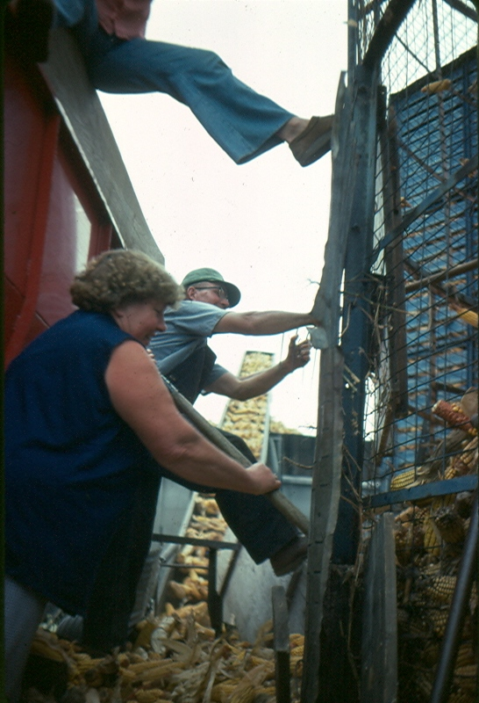
My father and mother’s work ethic rubbed off on all their children. In forty years they never missed a milking. She fed calves and drove in the cows daily. She was always out in the fields helping Daddy with baling, disking, mowing, hauling manure and filling the silo.
Her relationship to my father was a model to her children. I do not think I ever heard her utter a harsh word to him or about him. She was never cross with us no matter how tired she was, and she was often kind to a fault. Her words of blessing and encouragement to me have blessed me enormously. I have always marveled at her cheerful and encouraging spirit. She has had a lot of opportunities to complain but always looks for the best in all.
She is an excellent housekeeper, too. She has never had a cluttered house. She had to mop the kitchen floor nightly because my father did not take his shoes off and often trudged in manure. She never complained. In fact, I do not think I have ever heard my mother complain about anything! She really is amazing.
Her service in the church was terrific! She taught a Lord’s Day evening class for the children. I learned so much. Her challenge was to each week teach us something we, including her, did not know before. What great times we had having her teach us. She faithfully taught each week in whatever was asked of her. She loved studying and learning from the Bible. What a legacy of Biblical knowledge she has left in the lives of those she taught!
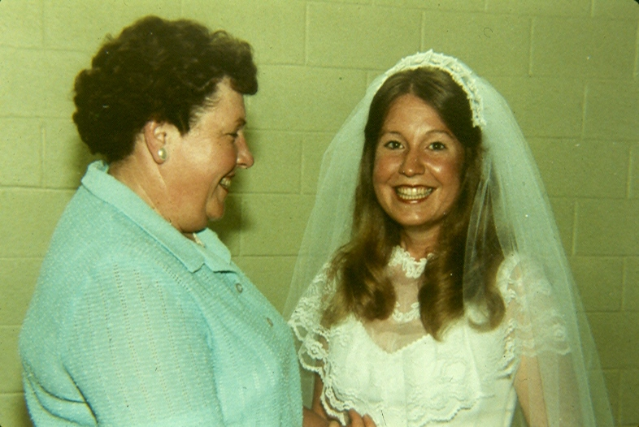
She would never like for me to go on and on about her.
Proverbs31
An excellent wife who can find? She is far more precious than jewels. The heart of her husband trusts in her, … She opens her mouth with wisdom, and the teaching of kindness is on her tongue. She looks well to the ways of her household and does not eat the bread of idleness. Her children rise up and call her blessed; her husband also, and he praises her: “Many women have done excellently, but you surpass them all.” Charm is deceitful, and beauty is vain, but a woman who fears the Lord is to be praised. (from Prov. 31, ESV)
I thank you for the opportunity to do just that!

Janet Keys Barker, April 3, 2015

