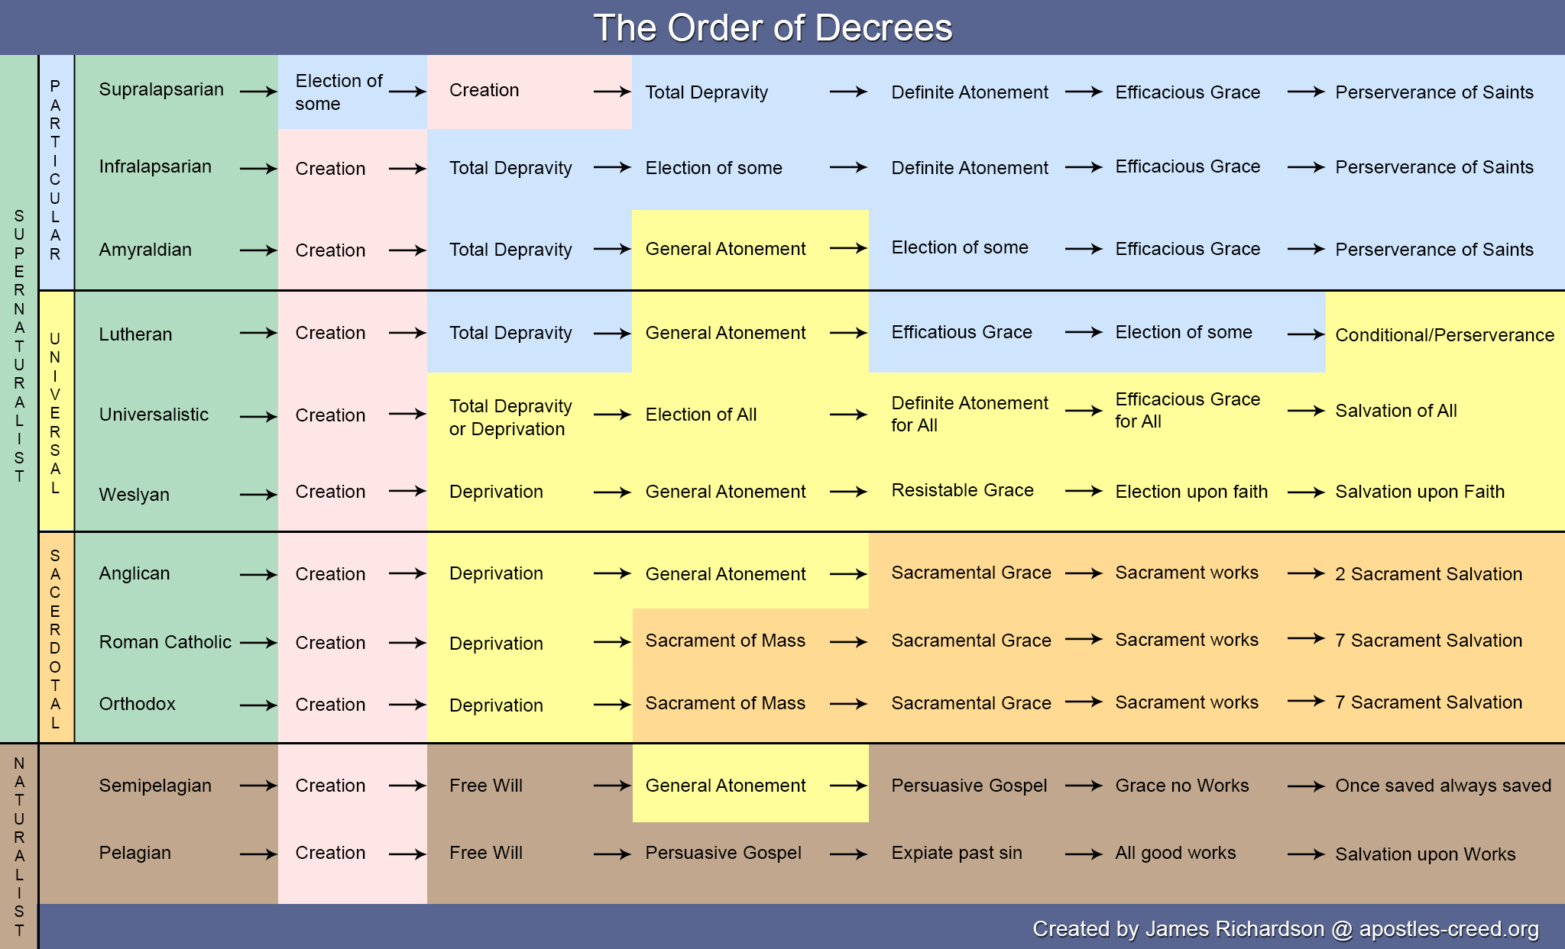

http://apostles-creed.org/confessional-reformed-christian-theology/soteriology/infographic-the-order-of-decrees-denominational-comparison-chart/