Notes Regarding the Characters in
Pilgrim's Progress
Lesson #01

The Unnamed Man – The Man is suddenly introduced – a typical figure, like Everyman in the old Morality Play. And the first thing noticeable about this ragged man is that his face is turned away from his own house. There are many things that set men’s faces from their own house – tempting sins, the craving for excitement and company, a roving fancy. But the only respectable one is Conscience, which si the cause of this man’s attitude.
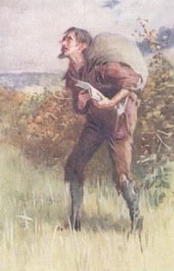
He is a man with a book. We all of us possess several books, but there are some whom one book possesses. It is of vast importance to choose carefully what book that shall be. A man’s one book will very likely become his tyrant. Here we have the Great Book doing its work. It has become the master of the man’s imagination, the tyrant of his conscience.
He is a man with a burden. Sin is often described by active and aggressive metaphors – it is a deceiver, a destroyer, an enemy, etc. This passive one is more dreadful, for it tells simply of the dead weight of fact. Sin is, to Paul, ‘this dead body’; and the flaccid mass of inelastic flesh, at once soft and heavy, is horrible enough without the implied hint of decay. The worst thing about sin is just that it is there – an irrevocable fact which the sinner has put there. When he realizes this he feels it as a burden: he cannot sleep, or eat, or work, or play as once he did. Yet that is a precious pain. The far deeper danger is that one should grow accustomed to it, until he is able complacently to ‘draw iniquity with a cart rope’. The unblushed-for past – the dead weight of sinful facts faced deliberately and carried lightly – that is a doom far deeper than the most oppressive load.
He is a man with a fear of punishment. The burden was not the fear of punishment, it was his sense of the fact of sin. Yet the fear of punishment is also a factor in the event. (The prodigal son came back to his father only when the fear of perishing came upon him; it was not a noble, but a very mean motive for coming, yet the main things is the fact that he came.) Amidst all his bewilderment one thing grows perfectly plain. He is terribly afraid of death. There is a light-hearted way of discounting death, and mocking the fear of it, which passes for courage, and is really mere slightness of intellect and poverty of conscience and imagination. The awfulness of death remains, felt by ineradicable instinct, and it was meant to remain. The subject may be called crude, harsh, morbid, it you like; but the winding-sheet, the coffin, and the six feet of earth are facts that wait for us. The spectre of death has risen with appalling clearness upon this man, because death is but the second last of terrors.
He is a man with a family. The man’s treatment by his family was an appeal to every form of human weakness. Deriding appealed to his self-esteem; chiding to his anger and his cowardice; neglect to his loneliness and need of friends. Some are mocked out of their highest destiny, others scolded out of it, others, who would have resisted active opposition, miss it through the humiliating experiences of neglect. It is this that is hardest of all to bear – the sensed of one’s utter insignificance, the quiet flow of the world past one.
He is a man with a prayer. He takes the high ground of certainty, ‘We are of God, and the whole world lieth in wickedness.’ Doubtless they would not thank him, but they would feel it. Nothing is so impressive as a man who is absolutely sure. It was not the man, but the man’s conscience that was the real hero. Nothing in the world is so heroic, after all, as to cuts one’s way alone through conventions and habits and troops of friends, out into the open, where there is no company but conscience, and no property but the burden of one’s own sin. (Kelman, pp. 3-8)

City of Destruction – We are all inhabitants of it. No man needs ask, Where is it? What is it? Who are its people? Alas! our world of sin is the City of Destruction, and we know of a certainty, from God’s word, that it is to be burned up, and that if we do not escape from it, though we may die at peace in it before its conflagration, yet to be found with its spirit in our souls when we die, is to be for ever miserable. (Cheever, p. ix)

Evangelist – The picture of the man is essentially that of a prophet. He is severe, austere, without those little human touches which make us feel in him a man, a brother. He is aloof and withdrawn. This air of authority and mastership is at once attractive and repellant. Evangelist-worship, with the excessive sense of the importance of the Evangelist’s own spiritual experiences and exploits, and the neurotic personal relations which are apt to follow is one of the perpetual dangers of his high office. This prophet’s authority rests on nothing but the sheer force of truth; his work is to send men away from himself to the light by which man must live. (Kelman, p. 8)
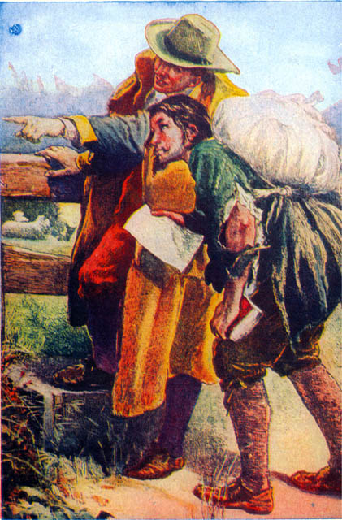
The first minister whose words were truly blessed of God for our awakening and conversion has always a place of his own in our hearts. We all have some minister, some revivalist, some faithful friend, or some good book in a warm place in our heart. (Whyte, pp 12-13)
Yes; why are we all so unwilling to die? Why do we number our days to put off our death to the last possible period? Why do we so refuse to think of the only things we are sure soon to come to? We are absolutely sure of nothing else in the future but death. We may not see tomorrow, but we shall certainly see the day of our death. And can it be for the same reason that made the man in rags unwilling to die? Is it because of the burden on our back? Is it because we are not fit to go to judgment? And yet the trumpet may sound summoning us hence before the midnight clock strikes. If this be thy condition, why standest thou still? (Whyte, p. 14)

The Wicket Gate – The wicket gate stands for an incident in life that will destroy the fear of death. The man cannot see it, and he says so frankly. At this stage he can see nothing clearly, for the whole region of religious truth is confused and obscure. No directions mean anything to him. The redeeming feature is that he says so frankly “No”. The exaggeration of experience, the too facile compliance with advice which one does not as yet understand, are the real dangers of this state. There is a shining light ahead, and Evangelist points him to that. Every soul of man can see at least some light of hope ahead, shining in the direction of the God or Christ or ideal which is as yet obscure. The point is, not that the light is full, or even comprehensible. If it be clear enough to flee towards, that is enough. What is wanted is directed motion towards the light; the rest will follow. So it comes to pass that one may be on the road to Christ when one cannot as yet see Him. (Kelman, pp. 8-9)
------------------------------------
Edited by Dr. David G Barker, www.ephesians515.com

notes taken from:
The Road: A Study of John Bunyan’s Pilgrim’s Progress by John Kelman, Edinburgh: Oliphant Anderson and Ferrier, 1911.
Lectures on the Pilgrim’s Progress by G.B. Cheever, Grants Pass, Oregon: SAT pub., 2000.
Bunyan Characters, by Alexander Whyte, Edinburgh: Oliphant Anderson and Ferrier, 1895.

