Notes Regarding the Characters in
Pilgrim's Progress
Lesson #00

Character Name – "The whole nomen-clature of The Pilgrim's Progress and of The Holy War is composed on the divine, original, and natural principle of embodying the nature of a man in his name. God takes his own names to Himself on that principle. The Creator gave Adam his name also on that same principle; and then Adam gave their names to all cattle, to the fowls of the air, and to every beast of the field on the same principle on which he had got his own name. and so it was at first with all the Bible names of men and of nations of men. Their name contained their nature. And John Bunyan was such a student of the Bible, and of no other book but the Bible, that all his best books are all full, like the Bible, of the most descriptive and suggestive names. As soon a Bunyan tells us the name of some new acquaintance or fellow-traveler, we already know him, so exactly is his nature put into his name." (Whyte, p. 89)

The Express Image - The word “character” occurs only once in the New Testament, and that is in the passage in the prologue of the Epistle to the Hebrews, where the original word is translated “express image” in our version. Our Lord is the Express Image of the Invisible Father. No man hath seen God at any time. The only-begotten Son, who is in the bosom of the Father, He hath declared Him. The Father hath sealed His divine image upon His Son, so that he that hath seen the Son hath seen the Father. The Son is thus the Father's character stamped upon and set forth in human nature. The Word was made flesh. This is the highest and best use to which our so expressive word “character” has ever been put, and the use to which it is put. For it is of the outstanding good or evil in a man that we think when we speak of his character. It is really either of his likeness or unlikeness to Jesus Christ we speak, and then, through Him, his likeness or unlikeness to God Himself.
And thus it is that the adjective “moral” usually accompanies our word “character” - moral or immoral. A man's character does not have its seat or source in his body; character is not a physical thing: not even in his mind; it is not an intellectual thing. Character comes up out of the will and out of the heart. There are more good minds, as we say, in the world than there are good hearts. There are more clever people than good people; character, - high, spotless, saintly character, - is a far rarer thing in this world than talent or even genius. Character is an infinitely better thing than either of these, and it is of corresponding rarity. And yet so true is it that the world loves its own, that all men worship talent, and even bodily strength and bodily beauty, while only one here and one there either understands or values or pursues moral character, though it is the strength and the beauty and the sweetness of the soul.
Do our characters come to be what they are by chance, or have we anything to do in the formation of our own characters, and if so, in what way? There are but three steps ... - acts, habits, character. For acts, often repeated, gradually become habits, and habits, long enough continued, settle and harden and solidify into character. ... [W]e are all with our own hands shaping our character not only for this world, but much more for the world to come, by every act we perform, by ever word we speak, almost by every breath we draw.
Our Lord Himself came to be the express image He was and is by living and acting under this same universal law of human life - acts, habits, character. He was made perfect on this same principle. He learned obedience both by the things that He did, and the things that He suffered. And those three foundation stones of our Lord's character settled deeper and grew stronger to bear and to suffer as He went on practicing acts and speaking words of justice, goodness, and truth. And so of all the other elements of His moral character. Our Lord left Gethsemane a much more submissive and a much more surrendered man than He entered it. His forgiveness of injuries, and thus His splendid benevolence, had not yet come to its climax and crown till He said on the cross, “Father, forgive them.” And, as He was, so are we in this world.
This world's evil and ill-desert made it but the better arena and theatre for the development and the display of His moral character; and the same instruments that fashioned Him into the perfect and express image He was and is, are still, happily, in full operation. Take that divinest and noblest of all instruments for the carving out and refining of moral character, the will of God. How our Lord made His own unselfish and unsinful will to bow to silence and to praise before the holy will of His Father, till that gave the finishing touch to His always sanctified will and heart! And, happily, that awful and blessed instrument for the formation of moral character is still active and available to those whose ambition rises to moral character, and who are aiming at heaven in all they do and all they suffer upon the earth. Its cup, if not in all the depth and strength of its first mixture, still in quite sufficient bitterness, is put many times in life into every man's hand. There is not a day, there is not an hour of the day, that the disciple of the submissive and all-surrendered Son has not the opportunity to say with his Master, “If it be possible, let this cup pass: nevertheless, not as I will, but as Thou wilt.”
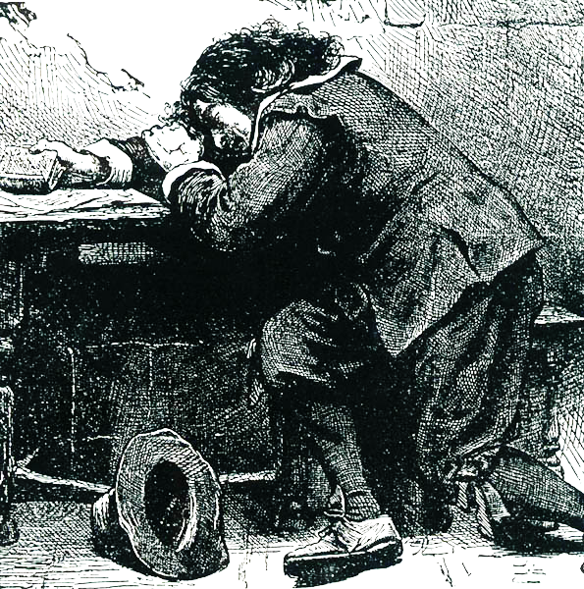
It is not in the great tragedies of life only that character is tested and strengthened and consolidated. No man who is not himself under God's moral and spiritual instruments could believe how often in the quietest, clearest, and least tempestuous day he has the chance and the call to say, “Yea, Lord, Thy will be done.” And, then, when the confessedly tragic days and nights come, when all men admit that this is Gethsemane indeed, the practiced soul is able, with a calmness and a peace that confound and offend the bystanders, to say, to act so that he does not need to say, “Not my will, but Thine.”
And so of all the other forms and features of moral character; so of humility and meekness, so of purity and temperance, so of magnanimity and munificence, so of all self-suppression and self-extinction, and all corresponding exalting and magnifying and benefiting of other men. Whatever other passing uses this present world, so full of trial and temptation and suffering, may have, this surely is the supreme and final use of it - to be a furnace, a graving house, a refining place for human character. Literally all things in this life and in this world - I challenge you to point out a single exception - work together for this supreme and only good, the purification, the refining, the testing, and the approval of human character.
Not only so, but we are all in the very heat of the furnace, and under the very graving iron and in the very refining fire that our prefigured and predestinated character needs. Your life and its trials would not suit the necessities of my moral character, and you would lose your soul beyond redemption if you exchanged lots with me. You do not put a pearl under the potter's wheel; you do not cast clay into a refining fire. Abraham’s character was not like David’s, nor David’s like Christ’s, nor Christ’s like Paul’s. As Butler says, there is “a providential disposition of things” around every one of us, and it is exactly suited to the flaws and excrescences, the faults and corruptions of our character as if Providence had had no other life to make a disposition of things for but one, and that one our own. Have you discovered that in your life, or any measure of that? Have you acknowledged to God that you have at last discovered the true key of your life? Have you given Him the satisfaction to know that He is not making His providential dispositions around a stock or a stone, but that He has one under His hand who understands His hand, and responds to it, and rises up to meet and salute it?
All else we possess and pursue shall fade and perish, our moral character shall alone survive. Riches, honours, possessions, pleasures of all kinds: death, with one stroke of his desolating hand, shall one day strip us bare to a winding-sheet and a coffin of all the things we are so mad to possess. But the last enemy, with all his malice and all his resistless power, cannot touch our moral character - unless it be in some way utterly mysterious to us that he is made under God to refine and perfect it.
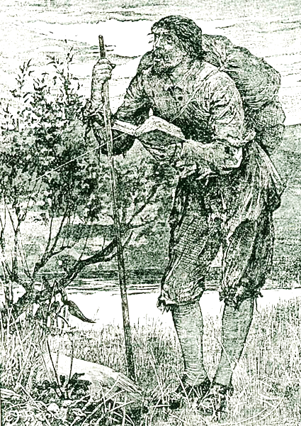
We shall carry our moral character to heaven; it is the only thing we have worth carrying so far. But, then, moral character is well worth achieving here and then carrying there, for it is nothing else and nothing less than the divine nature itself; it is the divine nature incarnate, incorporate, and made manifest in man. And it is, therefore, immortal with the immortality of God, and blessed forever with the blessedness of God. (Whyte, pp. 1-9)

Opening Scenerio - To the realist concerning this decadent modern age, the opening words are both arresting and intriguing. Having read the whole of the first paragraph, one is immediately made aware of the fact that this allegory is seriously and vitally concerned with the plight and destiny of mankind in its common predicament, not mere moralistic platitudes. … The commencing scene is that of the world fittingly described as a moral “wilderness,” or desolate planet, the allusion being to the wilderness wanderings of Israel in the Sinai Peninsula (Neh. 9:19, 21; Ps. 78:40, 52). Man’s present abode is not perceived even as a moderate paradise, but rather as an arid region where souls shrivel under the heat of sin’s glare and lack of the life of God, and the flesh burns with consuming desires. It is a place void of the true praise of God such as is continual in heaven; only predatory human beasts roam about, seeking to competitively devour each other so as to individually establish their exclusive, autonomous, ungodly reign. It is a place where Christians must necessarily pass through as ambassadors in enemy territory (II Cor. 5:20; Eph. 5:15-16), and are regarded as the scum and dregs of society (I Cor. 4:13). (Horner, ch. 1, pp. 40)

------------------------------------
Edited by Dr. David G Barker, www.ephesians515.com

notes taken from:
Bunyan Characters in the Pilgrim's Progress by Alexander Whyte, London:Oliphant Anderson and Ferrier, 1902.

