Train Trip from Paris to Milan

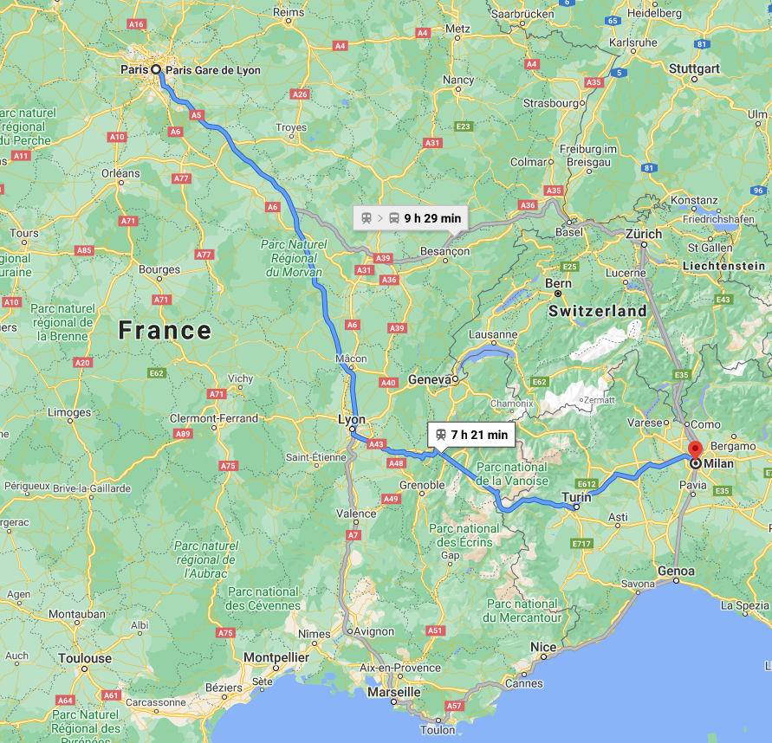
Turin
Geneva
Lyon

What you will miss seeing along the way.

