History

Pre-Norman cathedral
Bede records that in AD 604 Augustine of Canterbury consecrated Mellitus as the first bishop to the Anglo-Saxon kingdom of the East Saxons and their king, Sæberht. Sæberht's uncle and overlord, Æthelberht, king of Kent, built a church dedicated to St Paul in London, as the seat of the new bishop.^{[5]} It is assumed, although not proved, that this first Anglo-Saxon cathedral stood on the same site as the later medieval and the present cathedrals.
On the death of Sæberht in about 616, his pagan sons expelled Mellitus from London, and the East Saxons reverted to paganism. The fate of the first cathedral building is unknown. Christianity was restored among the East Saxons in the late 7th century and it is presumed that either the Anglo-Saxon cathedral was restored or a new building erected as the seat of bishops such as Cedd, Wine and Earconwald, the last of whom was buried in the cathedral in 693. This building, or a successor, was destroyed by fire in 962, but rebuilt in the same year.^{[6][page needed]}
King Æthelred the Unready was buried in the cathedral on his death in 1016; the tomb is now lost. The cathedral was burnt, with much of the city, in a fire in 1087, as recorded in the Anglo-Saxon Chronicle.^{[7]}

Cathedral or temple before 604 AD?
There is evidence for Christianity in London during the Roman period, but no firm evidence for the location of churches or a cathedral. London is said to have sent 2 delegates to the Council of Arles in 314 AD.
A list of the 16 "archbishops" of London was recorded by Jocelyn of Furness in the 12th century, claiming London's Christian community was founded in the 2nd century under the legendary King Lucius and his missionary saints Fagan, Deruvian, Elvanus and Medwin. None of that is considered credible by modern historians but, although the surviving text is problematic, either Bishop Restitutus or Adelphius at the 314 Council of Arles seems to have come from Londinium.^{[a]}
The location of Londinium's original cathedral is unknown. But legend and medieval tradition claims it was St Peter upon Cornhill. St Paul is an unusual attribution for a cathedral, and suggests there was another one in the Roman period. Legends of St Lucius link St Peter upon Cornhill as the centre of the Roman Londinium Christian community. It stands upon the highest point in the area of old Londinium, and it was given pre-eminence in medieval procession on account of the legends. There is, however, no other reliable evidence and the location of the site on the Forum makes it difficult for it to fit the legendary stories. In 1995, a large 5th-century building on Tower Hill was excavated, and has been claimed as a Roman basilica, possibly a cathedral, although this is speculative. ^{[8][9]}
The Elizabethan antiquarian William Camden argued that a temple to the goddess Diana had stood during Roman times on the site occupied by the medieval St Paul's Cathedral.^{[10]} Wren reported that he had found no trace of any such temple during the works to build the new cathedral after the Great Fire, and Camden's hypothesis is no longer accepted by modern archaeologists.^{[11]}

Old St Paul's
Main article: Old St Paul's Cathedral
The fourth St Paul's, generally referred to as Old St Paul's, was begun by the Normans after the 1087 fire. A further fire in 1135 disrupted the work, and the new cathedral was not consecrated until 1240. During the period of construction, the style of architecture had changed from Romanesque to Gothic and this was reflected in the pointed arches and larger windows of the upper parts and East End of the building. The Gothic ribbed vault was constructed, like that of York Minster, of wood rather than stone, which affected the ultimate fate of the building.^{[citation needed]}
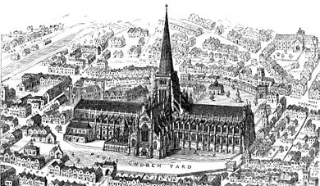
Reconstructed image of Old St Paul's before 1561, with intact spire
An enlargement programme commenced in 1256. This "New Work" was consecrated in 1300 but not complete until 1314. During the later Medieval period St Paul's was exceeded in length only by the Abbey Church of Cluny and in the height of its spire only by Lincoln Cathedral and St. Mary's Church, Stralsund. Excavations by Francis Penrose in 1878 showed that it was 585 feet (178 m) long and 100 feet (30 m) wide (290 feet or 87 m across the transepts and crossing). The spire was about 489 feet (149 m) in height.^{[citation needed]}
By the 16th century the building was starting to decay. The English Reformation under Henry VIII and Edward VI, and particularly the Chantries Acts led to the destruction of elements of the interior ornamentation and the chapels, shrines, chantries. In October 1538, an image of St Erkenwald, probably from the shrine, was delivered to the master of the king’s jewels. Other images may have survived, at least for a time. More systematic iconoclasm happened in the reign of Edward VI; the Grey Friar’s Chronicle reports that the rood and other images were destroyed in November 1547, and "Alle the alteres and chappelles in alle Powlles churche" were taken down in October 1552.^{[12]} Some of the buildings in St Paul's Churchyard were sold as shops and rental properties, especially to printers and booksellers. In 1561 the spire was destroyed by lightning, an event that Roman Catholics writers claimed was a sign of God's judgement on England's Protestant rulers. Bishop James Pilkington preached a sermon in response, claiming that the lightning strike was a judgement for the irreverent use of the cathedral building.^{[13]} Immediate steps were taken to repair the damage, and the citizens of London and the clergy offering money to support the rebuilding.^{[14]} But the cost of repairing the building properly was too great for a country and city recovering from a trade depression. Instead, the roof was repaired and a timber "roo"’ put on the steeple. In the 1630s a west front was added to the building by England's first classical architect, Inigo Jones. There was much defacing and mistreatment of the building by Parliamentarian forces during the Civil War, and the old documents and charters were dispersed and destroyed.^{[15][page needed]} During the Commonwealth, those churchyard buildings that were razed supplied ready-dressed building material for construction projects, such as the Lord Protector's city palace, Somerset House. Crowds were drawn to the north-east corner of the churchyard, St Paul's Cross, where open-air preaching took place.^{[citation needed]}
In the Great Fire of London of 1666, Old St Paul's was gutted.^{[16]} While it might have been possible to reconstruct it, a decision was taken to build a new cathedral in a modern style. This course of action had been proposed even before the fire.

Present St Paul's
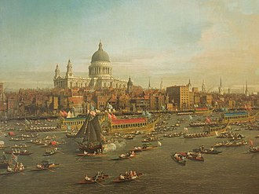
Canaletto: The River Thames with St. Paul's Cathedral on Lord Mayor's Day (1746; Lobkowicz Collections, Prague)
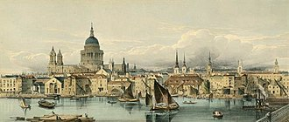
Boats on the River Thames and St Paul's Cathedral, 1850s
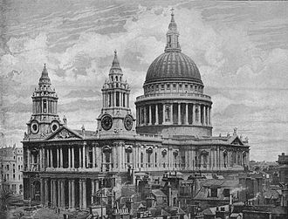
St Paul's Cathedral in 1896
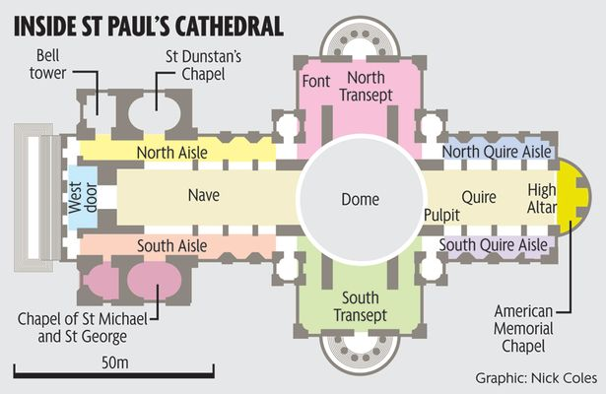
The task of designing a replacement structure was officially assigned to Sir Christopher Wren on 30 July 1669.^{[17]} He had previously been put in charge of the rebuilding of churches to replace those lost in the Great Fire. More than 50 City churches are attributable to Wren. Concurrent with designing St Paul's, Wren was engaged in the production of his five Tracts on Architecture.^{[18][page needed]}
Wren had begun advising on the repair of the Old St Paul's in 1661, five years before the fire in 1666.^{[19]} The proposed work included renovations to interior and exterior to complement the classical facade designed by Inigo Jones in 1630.^{[20]} Wren planned to replace the dilapidated tower with a dome, using the existing structure as a scaffold. He produced a drawing of the proposed dome which shows his idea that it should span nave and aisles at the crossing.^{[21]} After the Fire, it was at first thought possible to retain a substantial part of the old cathedral, but ultimately the entire structure was demolished in the early 1670s.
In July 1668 Dean William Sancroft wrote to Wren that he was charged by the Archbishop of Canterbury, in agreement with the Bishops of London and Oxford, to design a new cathedral that was "Handsome and noble to all the ends of it and to the reputation of the City and the nation".^{[22]} The design process took several years, but a design was finally settled and attached to a royal warrant, with the proviso that Wren was permitted to make any further changes that he deemed necessary. The result was the present St Paul's Cathedral, still the second largest church in Britain, with a dome proclaimed as the finest in the world.^{[23]} The building was financed by a tax on coal, and was completed within its architect's lifetime with many of the major contractors engaged for the duration.
The "topping out" of the cathedral (when the final stone was placed on the lantern) took place on 26 October 1708, performed by Wren's son Christopher Jr and the son of one of the masons.^{[24]} The cathedral was declared officially complete by Parliament on 25 December 1711 (Christmas Day).^{[25]} In fact, construction continued for several years after that, with the statues on the roof added in the 1720s. In 1716 the total costs amounted to £1,095,556^{[26]} (£165 million in 2019).^{[27]}

Consecration
On 2 December 1697, 31 years and 3 months after the Great Fire destroyed Old St Paul's, the new cathedral was consecrated for use. The Right Reverend Henry Compton, Bishop of London, preached the sermon. It was based on the text of Psalm 122, "I was glad when they said unto me: Let us go into the house of the Lord." The first regular service was held on the following Sunday.
Opinions of Wren's cathedral differed, with some loving it: "Without, within, below, above, the eye / Is filled with unrestrained delight",^{[28][page needed]} while others hated it: "There was an air of Popery about the gilded capitals, the heavy arches ... They were unfamiliar, un-English ...".^{[29]}

Since 1900

War damage
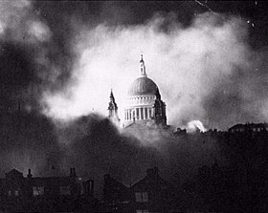
The iconic St Paul's Survives taken on 29 December 1940 of St Paul's during the Blitz
The cathedral survived the Blitz although struck by bombs on 10 October 1940 and 17 April 1941. The first strike destroyed the high altar, while the second strike on the north transept left a hole in the floor above the crypt.^{[30][31][better source needed]} The latter bomb is believed to have detonated in the upper interior above the north transept and the force was sufficient to shift the entire dome laterally by a small amount.^{[32][33]}
On 12 September 1940 a time-delayed bomb that had struck the cathedral was successfully defused and removed by a bomb disposal detachment of Royal Engineers under the command of Temporary Lieutenant Robert Davies. Had this bomb detonated, it would have totally destroyed the cathedral; it left a 100-foot (30 m) crater when later remotely detonated in a secure location.^{[34]} As a result of this action, Davies and Sapper George Cameron Wylie were each awarded the George Cross.^{[35]} Davies' George Cross and other medals are on display at the Imperial War Museum, London.
One of the best known images of London during the war was a photograph of St Paul's taken on 29 December 1940 during the "Second Great Fire of London" by photographer Herbert Mason, from the roof of a building in Tudor Street showing the cathedral shrouded in smoke. Lisa Jardine of Queen Mary, University of London, has written:^{[30]}
Wreathed in billowing smoke, amidst the chaos and destruction of war, the pale dome stands proud and glorious—indomitable. At the height of that air-raid, Sir Winston Churchill telephoned the Guildhall to insist that all fire-fighting resources be directed at St Paul's. The cathedral must be saved, he said, damage to the fabric would sap the morale of the country.

