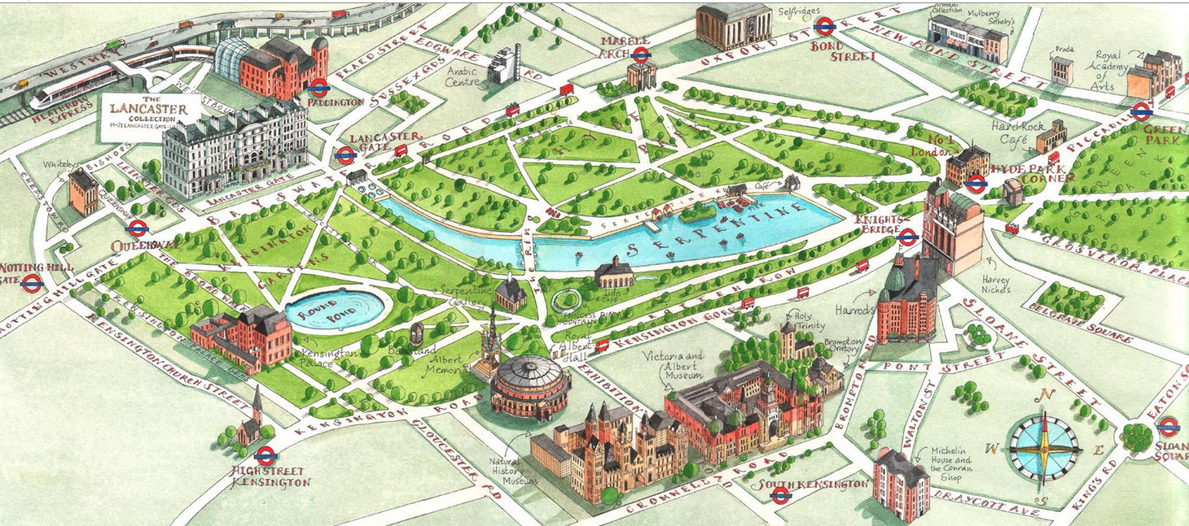

Hyde Park

Website: www.royalparks.org.uk/parks/hyde-park

Hyde Park is a Grade I-listed major park in Central London. It is the largest of four Royal Parks that form a chain from the entrance of Kensington Palace through Kensington Gardens and Hyde Park, via Hyde Park Corner and Green Park past the main entrance to Buckingham Palace. The park is divided by the Serpentine and the Long Water lakes.
The park was established by Henry VIII in 1536 when he took the land from Westminster Abbey and used it as a hunting ground. It opened to the public in 1637 and quickly became popular, particularly for May Day parades. Major improvements occurred in the early 18th century under the direction of Queen Caroline. Several duels took place in Hyde Park during this time, often involving members of the nobility. The Great Exhibition of 1851 was held in the park, for which The Crystal Palace, designed by Joseph Paxton, was erected.
Free speech and demonstrations have been a key feature of Hyde Park since the 19th century. Speakers' Corner has been established as a point of free speech and debate since 1872, while the Chartists, the Reform League, the suffragettes, and the Stop the War Coalition have all held protests there. In the late 20th century, the park was known for holding large-scale free rock music concerts, featuring groups such as Pink Floyd, The Rolling Stones and Queen. Major events in the park have continued into the 21st century, such as Live 8 in 2005, and the annual Hyde Park Winter Wonderland from 2007.
For further information: https://en.wikipedia.org/wiki/Hyde_Park,_London

